UMB Concur Travel & Expense System Role Validation Instructions
Purpose: Instructions for accessing the Concur Travel & Expense System Role Validation report and Jira to complete the role validation process. Note: to run this report you must hold the Consumer Role. If unsure who has this role in your department, please reach out for assistance to rolevalidation@umaryland.edu.

Sign into myUMB and select:
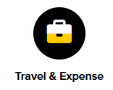

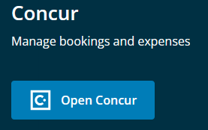
Open Concur through the CTM Portal Page

Navigate into Reporting > Intelligence:
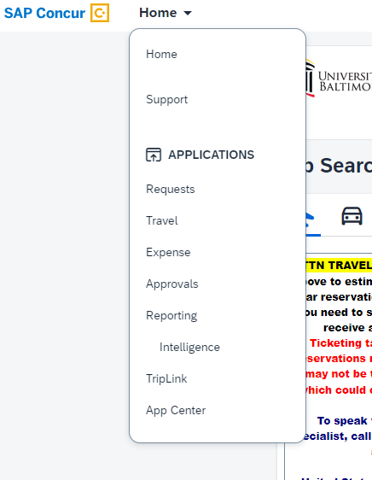

Navigate to Content
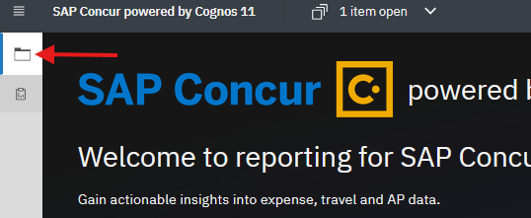

Navigate to Team Content > University of Maryland, Baltimore:

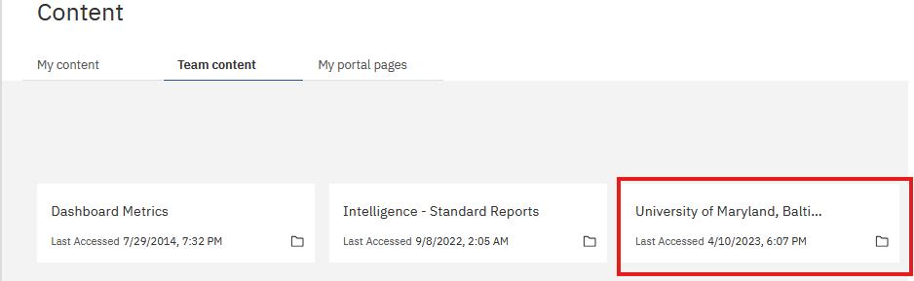

Navigate to End User Reports:
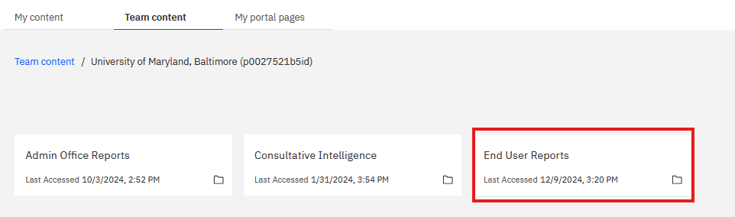

Navigate to Role Validation – DTA and CCA:

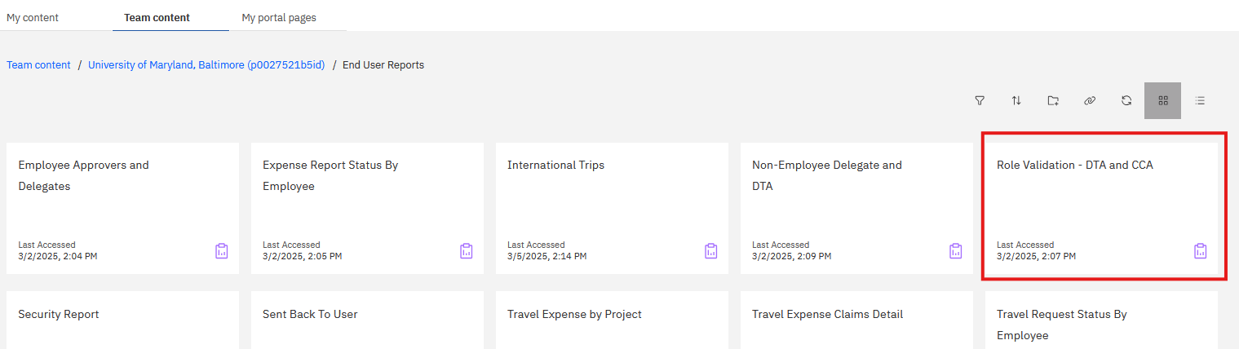

Select the Org(s) for your Department and click Finish:
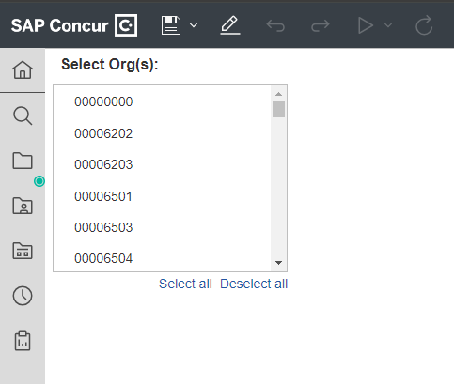

- Results will include the prompts you entered, users and their security roles and certification statement for the School, Department(s), or Org(s) you entered and signature lines.

- Validate that everyone is still a valid employee and has the appropriate roles for their job duties. If any changes need to be made, submit a Concur Form. Updates may take up to two business days. After the role updates are made, run the same report again to get a final version.

Click on the arrow next to the play button and select Run PDF:
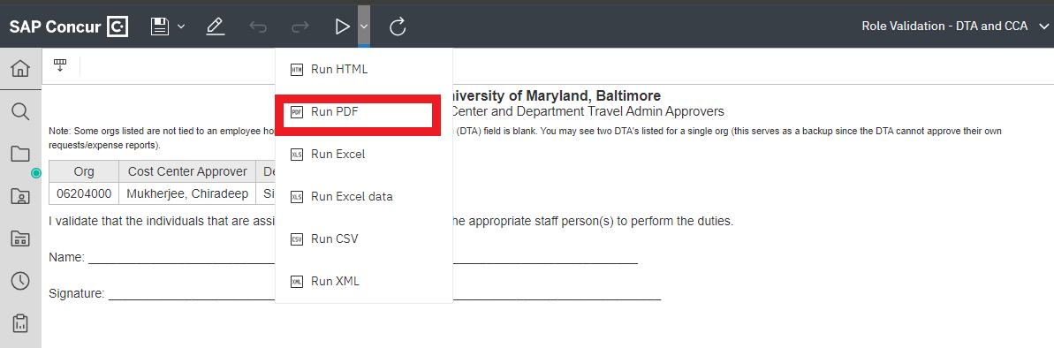

Once you have validated the final version of the User Security Roles PDF report, select the printer icon in the top right corner and choose the Destination “Save as PDF” then click “Save” to name the file and save it in a folder of your choosing.

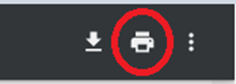
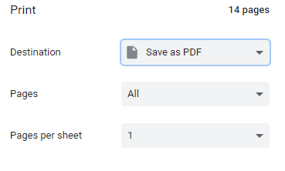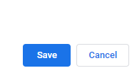

Select Role Validation Form from the User Authorization Forms list.
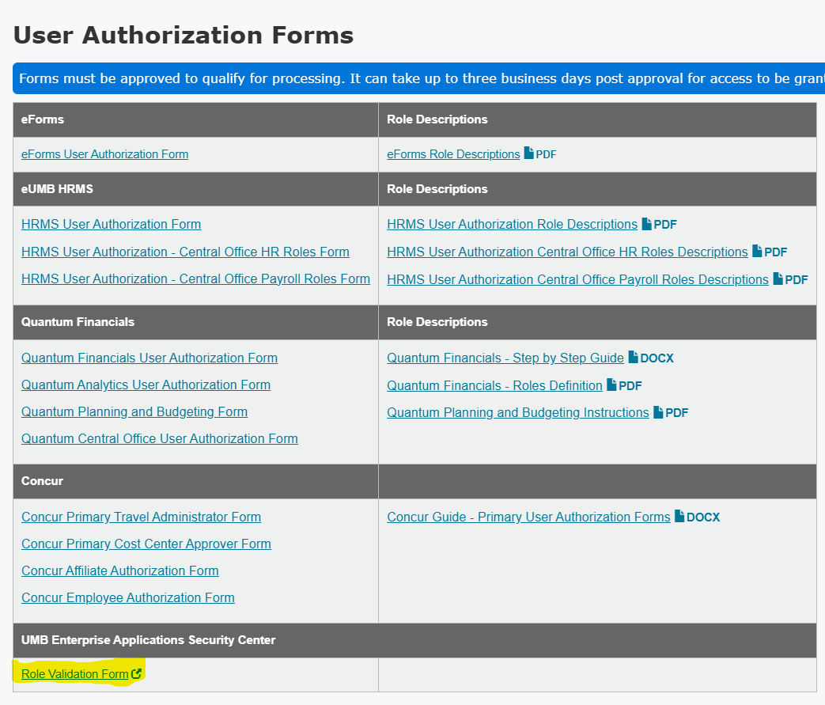

Click “Submit a Role Validation Report.”
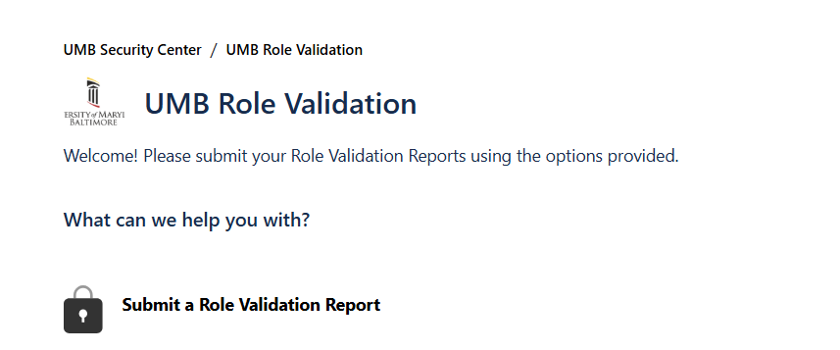

Enter the Required fields.
  - Summary: Description of which forms you are submitting – note you can submit all role validations at once using this form, but should only submit those together that can be approved by the same Approver.
  - Additional Notes or Comments: Provide any additional details you feel are necessary.
  - Applications: Select Concur (you can select multiple, if you are also submitting Financials and HCM at the same time).
  - Department Range: Enter departments as a range or comma-delimited list.
  - Attachment: Drag all role validation files being submitted.
  - Requestor Name: (Your name)
  - Requestor Email: (Your email)
  - Approver Name: (Approver’s name)
  - Approver Email: (Approver’s email)
  - Approval Certification: Check the box certifying the approver has reviewed and approved the forms that have been attached.
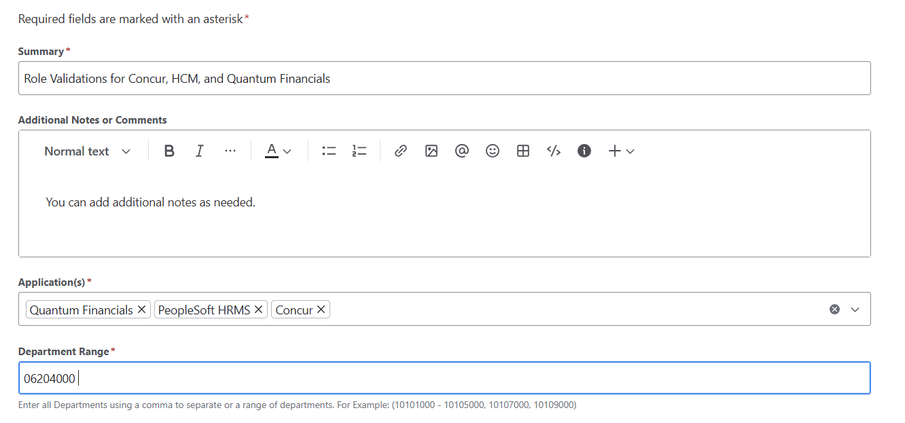
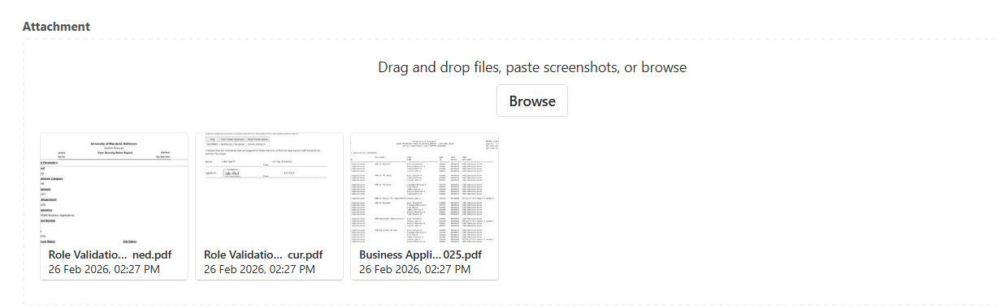
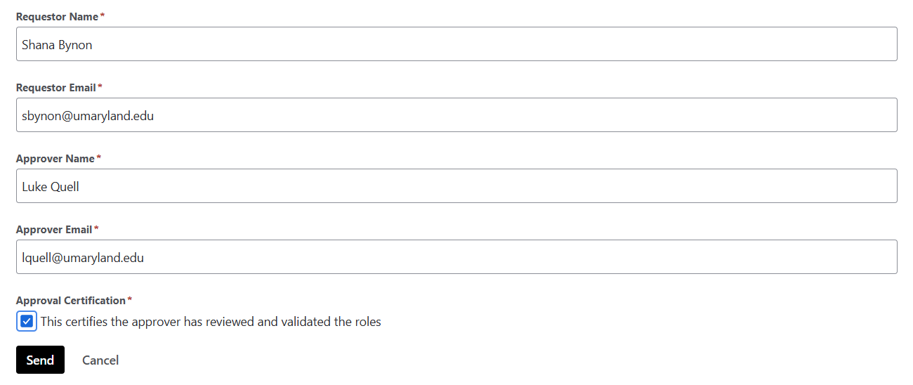

Click the “Send” button. Review the results.
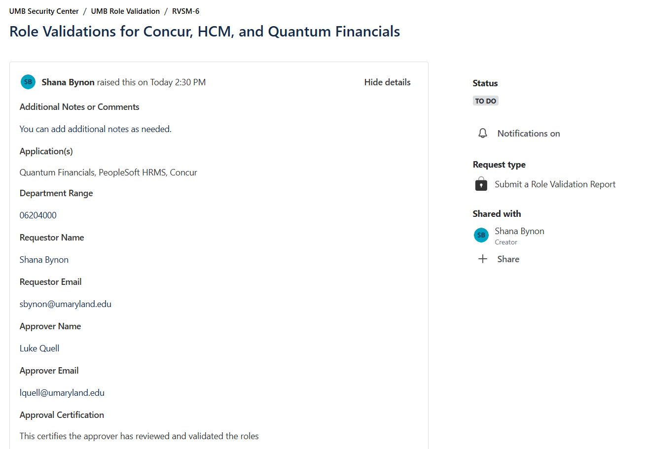
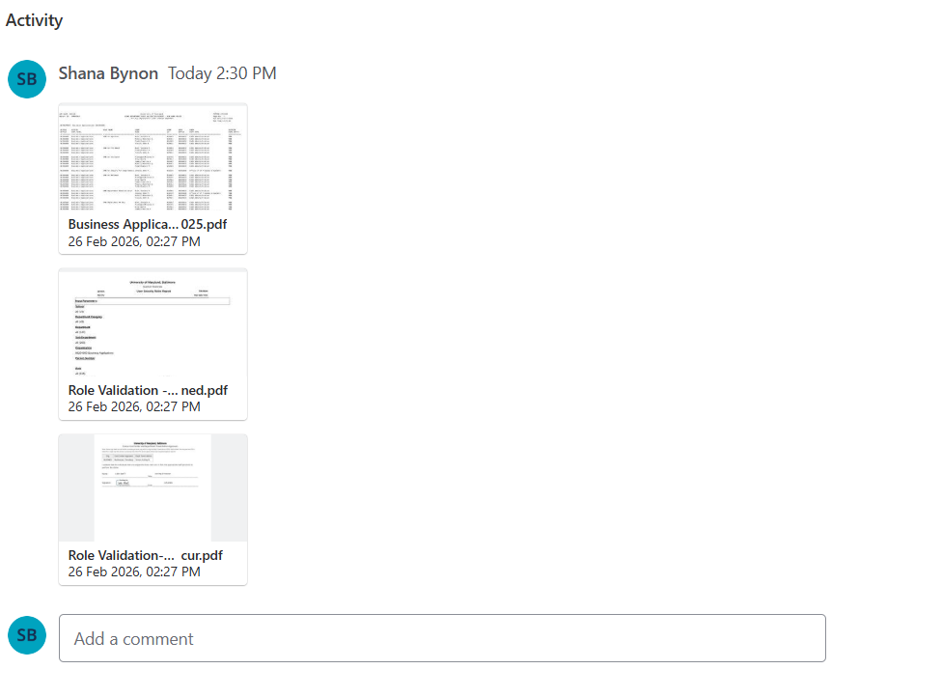

If desired, click “Share” to add your approver to the request. This will allow the approver to access to the request, view the attachments and make comments.
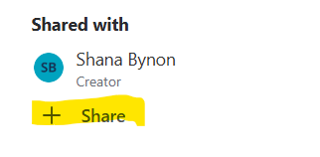
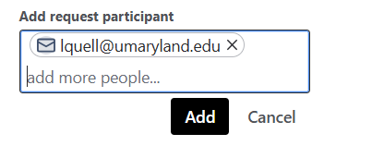
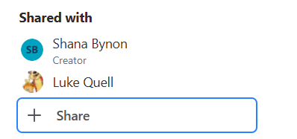

To access the request later via the UMB Security Center:
  - Click on the “View Request” link in your share notification.
  - The View Request link redirects to the request in the UMB Security Center.

Business Applications will be notified that your forms have been submitted. If you have questions, you can email rolevalidation@umaryland.edu.

