Creating Travel Requests Using CONCUR Event Manager
The Concur Event Manager role allows a Travel Administrator to create travel events for multiple travelers who are all going on the same trip. The Event Manager role is a separate role from the regular traveler role(s).
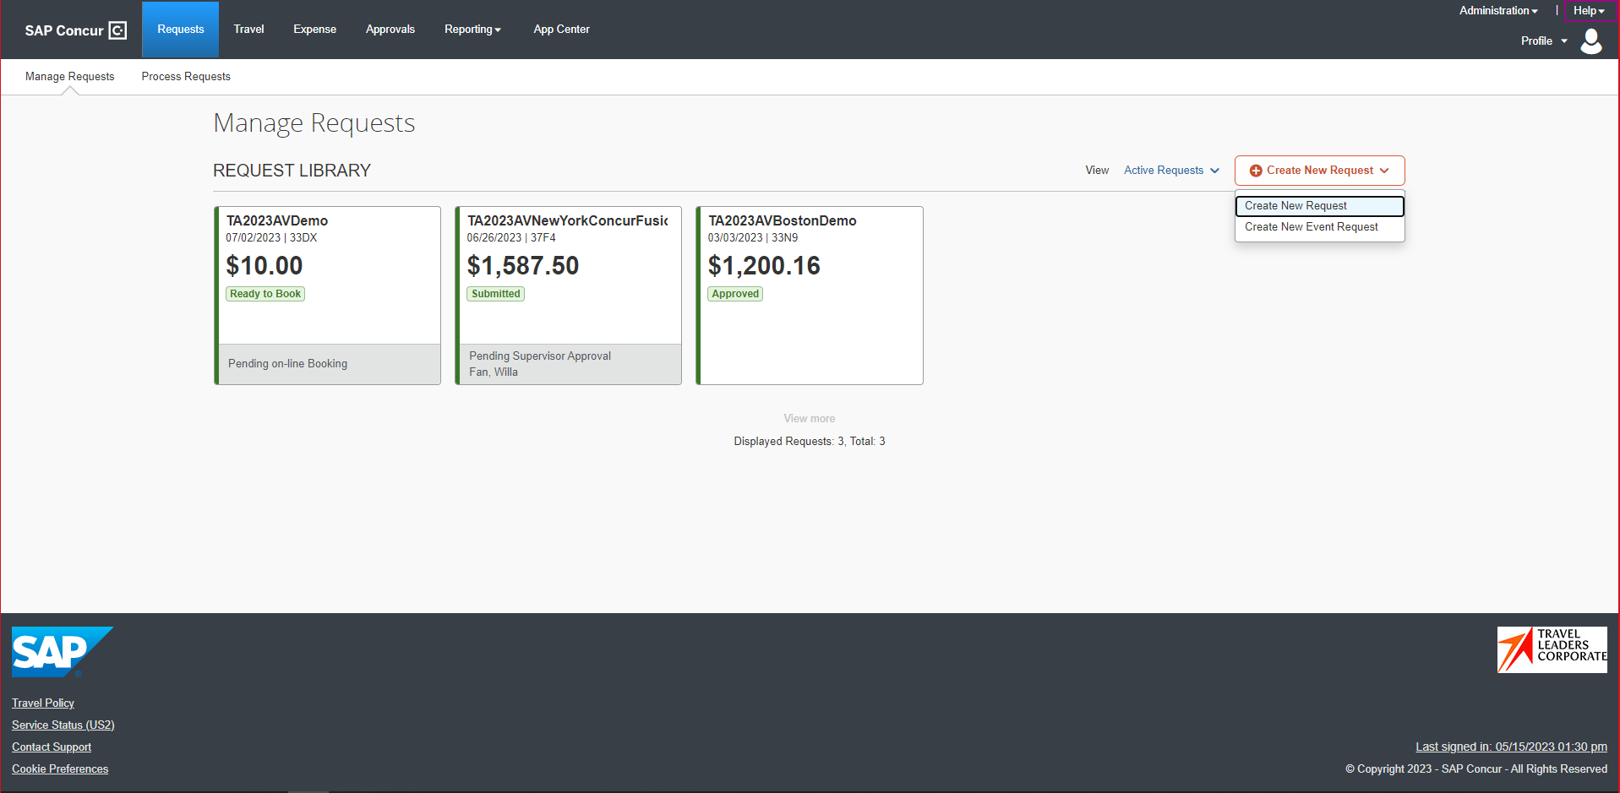
To begin, open Concur’s Home Page and select the Requests tab.
The Request Library will open, as shown.
To the right of the Create New Request link, click the dropdown and select Create New Event Request.
The system will open a blank Header page.

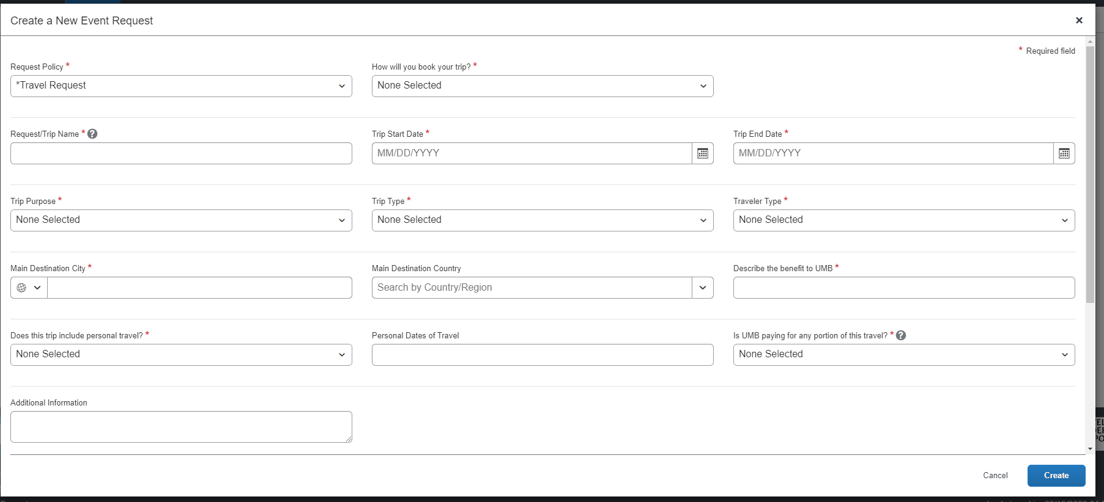
On the Header, enter all details of the trip for the multiple parties attending.
- Booking Type
- Trip Request Name
- Trip Start and End dates
- Trip Purpose
- Trip Type
- Traveler Type
- Destination City
- Describe the Benefit to UMB
- Is UMB Paying for any Portion of this travel
- Additional Information: Enter comments about the group travel, such as Trip to Denver for research presentation with PI and research assistants
Scroll down and enter or select the main funding source for this travel event in the PROJECT/SOAPF fields. When the Header is complete, click Create at the bottom of the page.

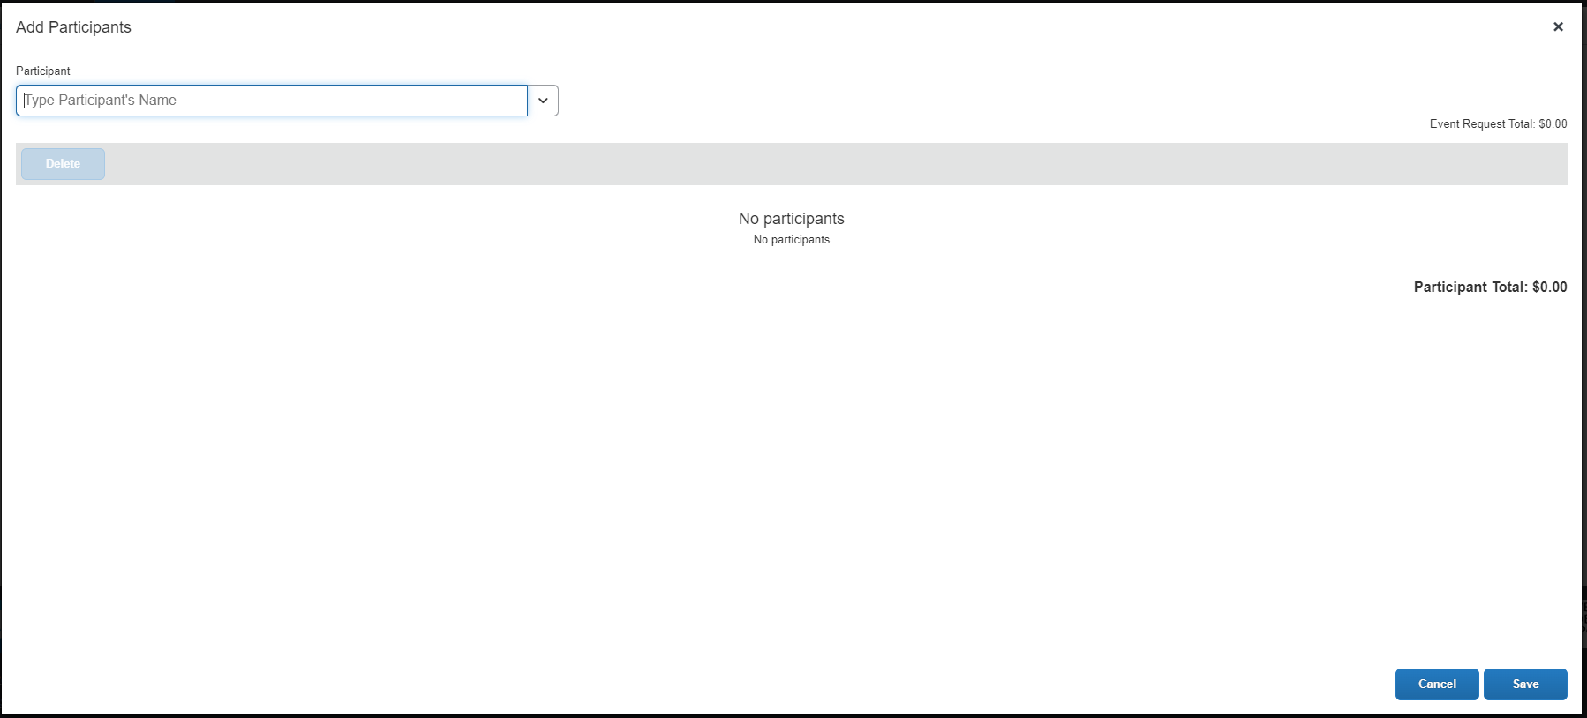
On the Add Participants screen, enter the name of the first traveler. The system will match the name you entered. You can then select it.
* Hint: If you cannot find a traveler, that person may be a non-employee or affiliate who needs a Concur profile created through a Security access form first.
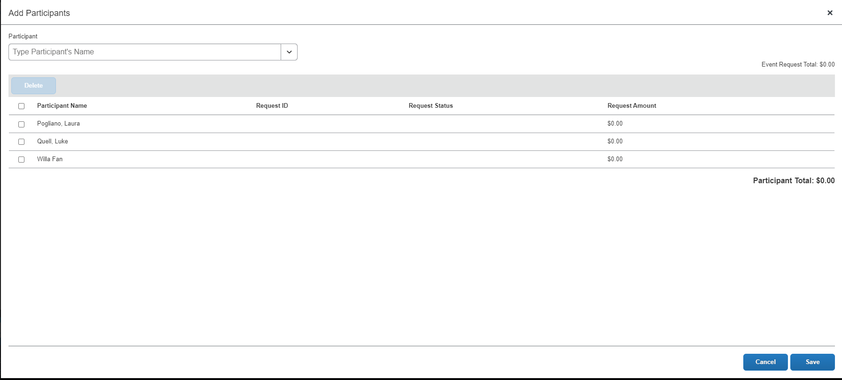
Continue to enter the travelers for the trip.
Note the Participant Total is currently 0.00. When you add an expense type and an amount, that amount will be multiplied by the number of travelers you’ve entered here.
When you’re done adding travelers, click Save at the bottom of the screen.
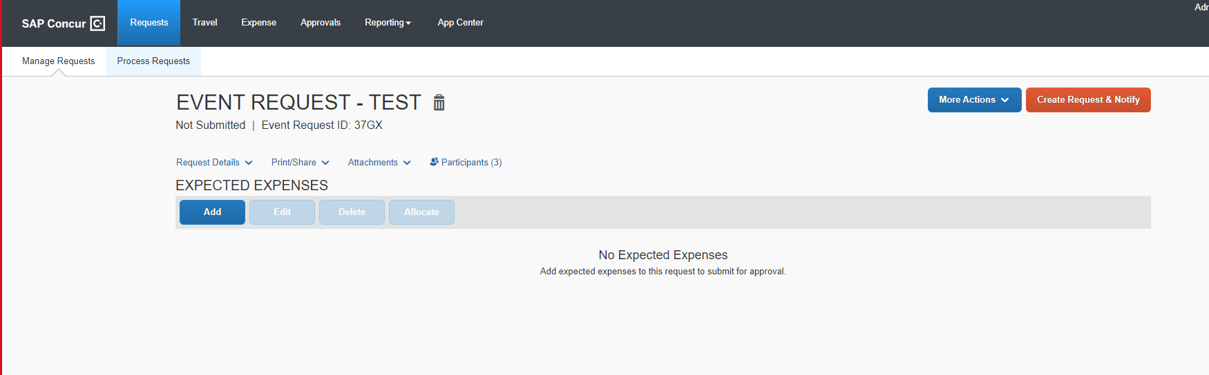
The Expected Expenses page is displayed, as shown.
Use the Add button under Expected Expenses to create expenses for this request, as shown below. The Expense types you select and complete will apply to all travelers.
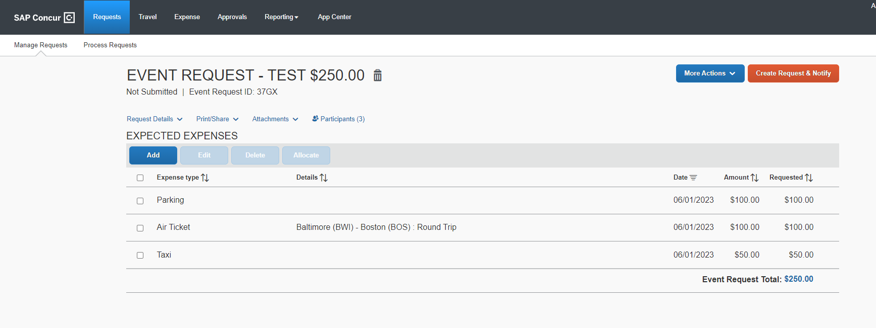
The Event Request Total is $250.00, the total for just the lines of the individual Expected Expenses.
To review the request totals for all Participants, click the Participants link.
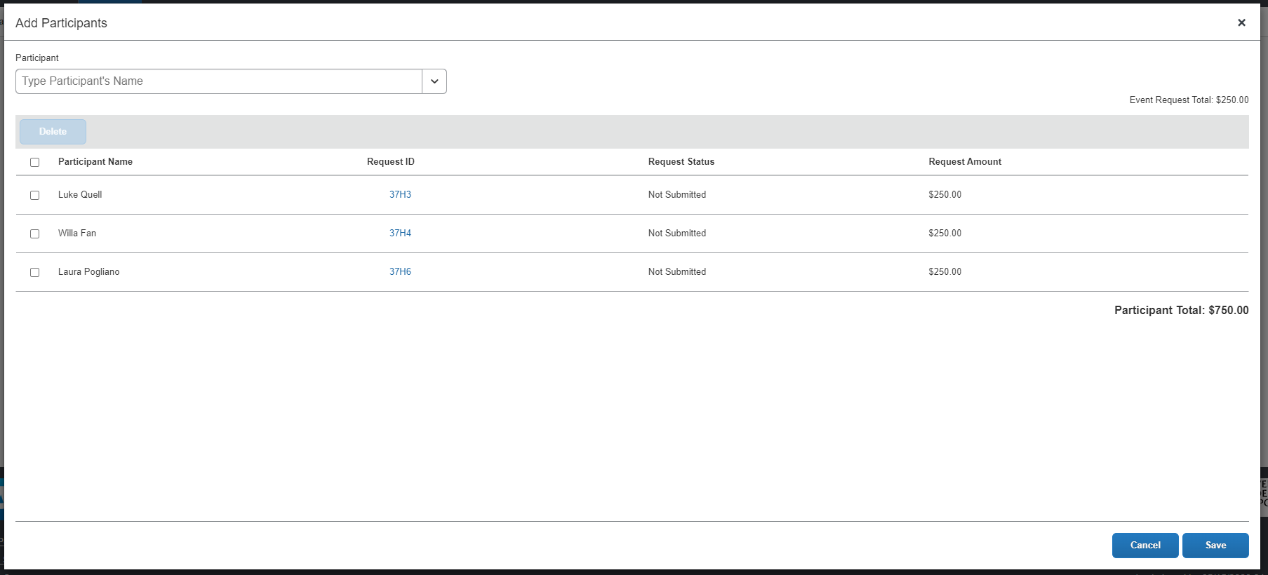
The Add Participants page is displayed.
As shown, the Participant Totals now reflect the cost of the trip for all travelers. *Hint: You can add more travelers or more expense types at any point before submitting this.
Note that the request status is Not Submitted. You can return to this screen at a later point to view the various stages of approval for each participant as the request moves through workflow.
Click Cancel if you have made no changes, or Save if you have made updates, to return to the Expected Expense page.
When all Participants (travelers) and Expected Expenses have been added, click Create Request & Notify. This action will send the request to all employee travelers to review and submit. For non-employee travelers, the Create Request & Notify button will read Create Request & Submit.
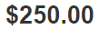
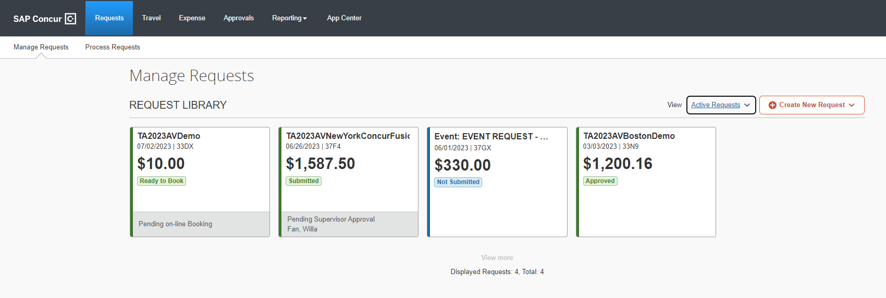
The Request Library page is returned with your Event displayed.

