Central Administration Support Services- CASS - VEOCI User Guide

https://veoci.com/v/p/dashboard/5w5z82r5ca

Accessing the System
- Log In to VEOCI
Begin by logging into the VEOCI portal using your standard credentials, just as you would for portal access.
When you click the link above or open the “Submit Request” tab on our Webpage the VEOCI login page will open.

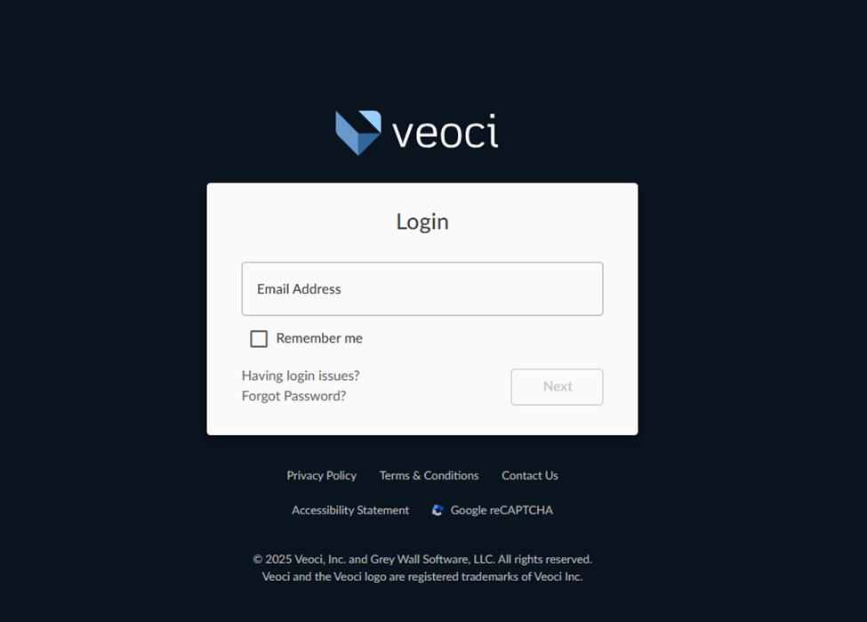

Click “UMID Login”. There is no need to create a login for VEOCI!

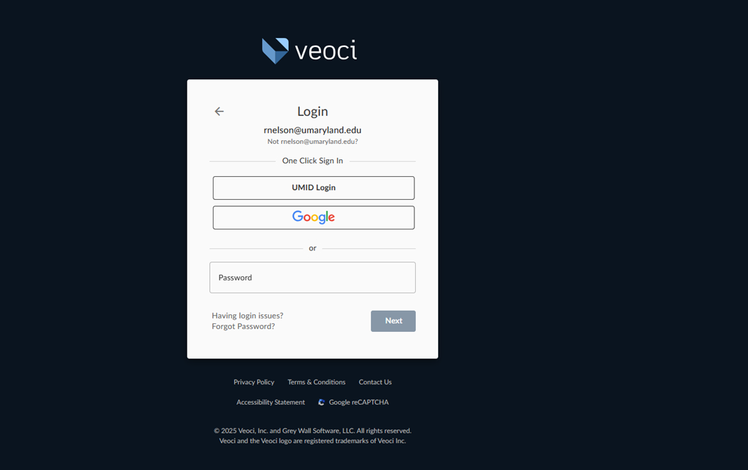

You will be prompted to login just as you would for the portal access.

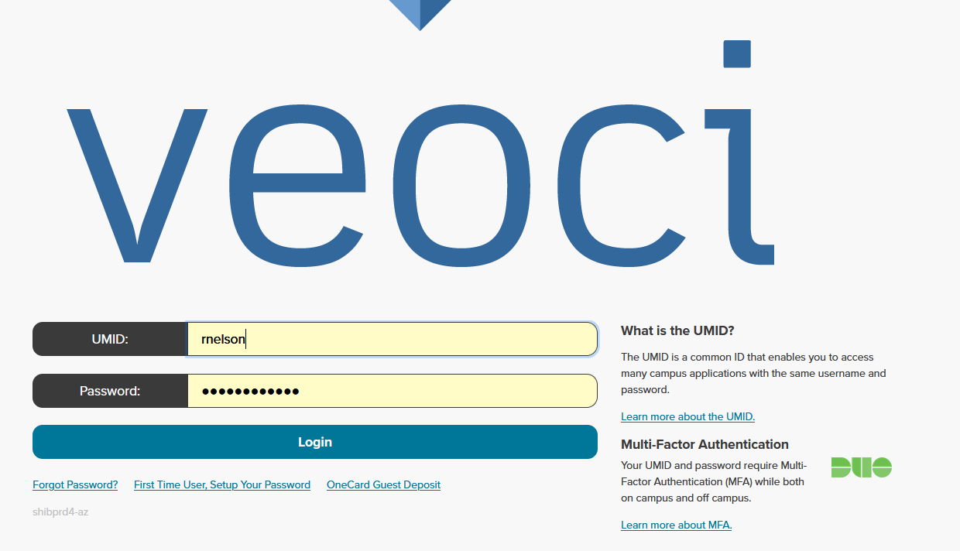

Submitting a Request Form

- Select Central Administration Support Services Request-

*When you login the system will open up to your dashboard page, see example below.

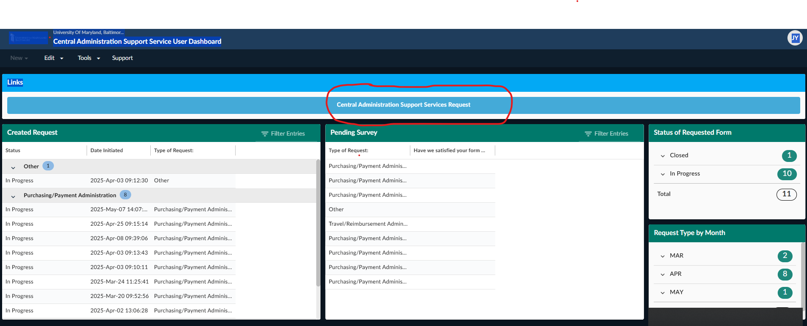

*From your dashboard select- Central Administration Support Services Request- see example below and above circled in red.

- Filling Out the Request Form

You will be prompted to fill out the necessary fields, basically the same as our previous request page.

Please see below-

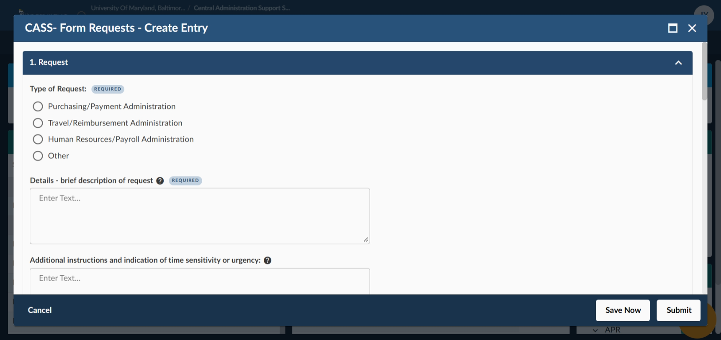

*Select type of request provide details and any additional instructions including time sensitivity/urgency and delivery instructions.

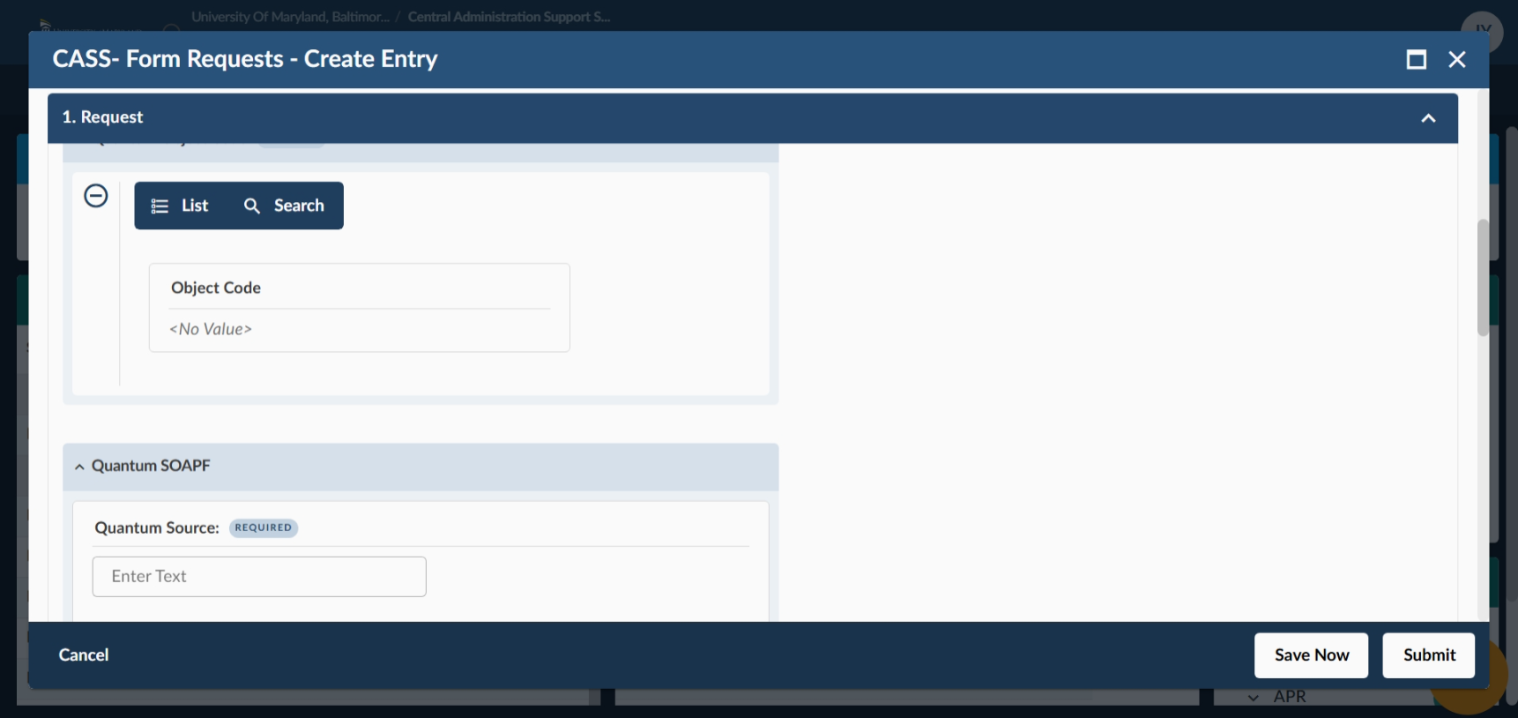

*use drop down menu to select object code.

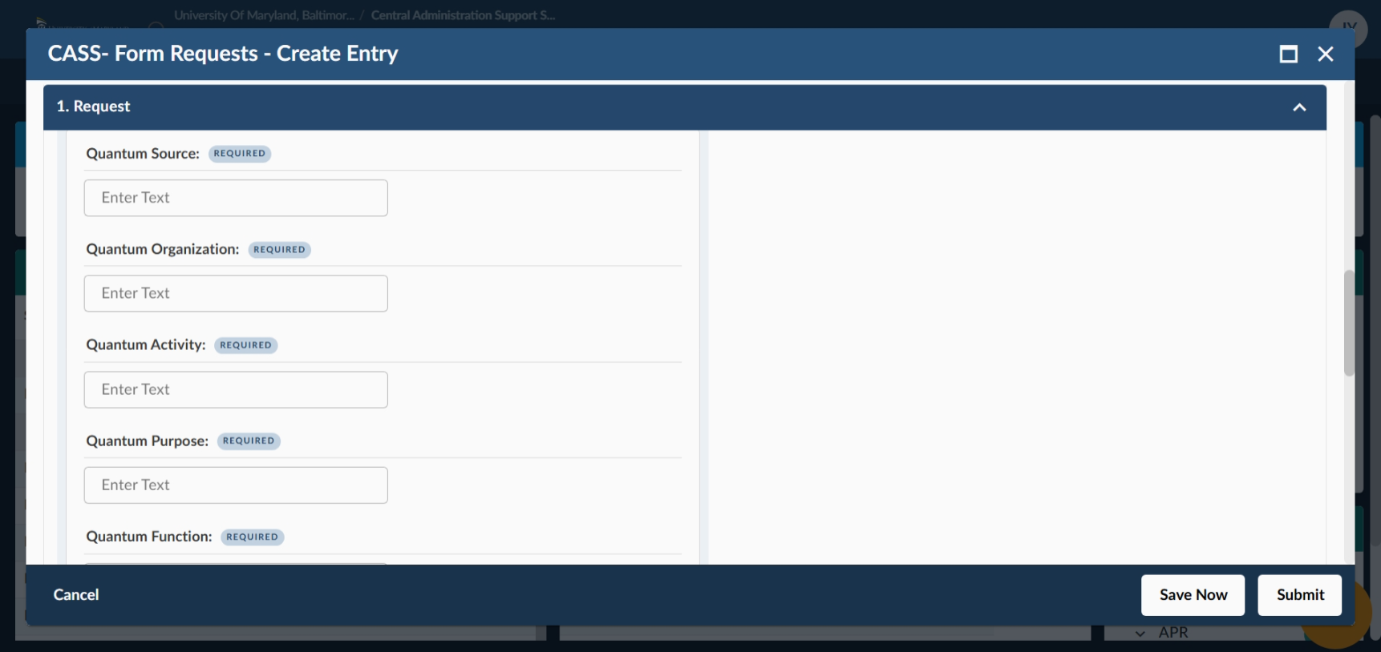

*Complete the required fields providing information on where request should be charged.

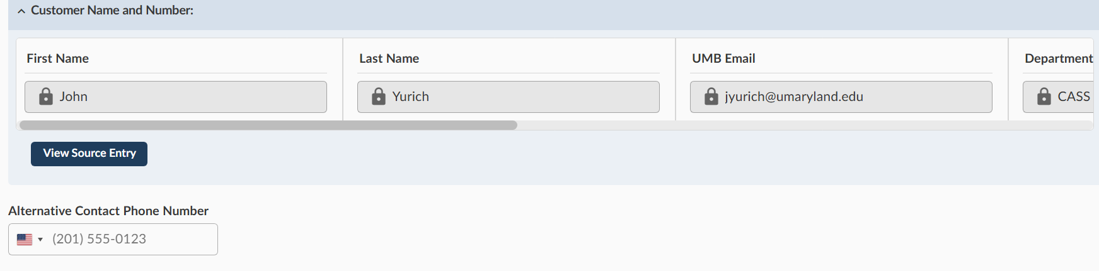

*Your UMB contact information will automatically be entered by the system. If you have an alternate contact phone number you can enter it as well.

- Attach Backup Documentation
Before submitting the form, ensure you have attached any necessary backup documentation to support your request.

If there is any additional information or if there is an alternate contact person for the request you can also enter this information in the – “Add a Comment section”.

Review and Submit

After filling out the form and ensuring all information is accurate and complete, click submit to send your request for processing.

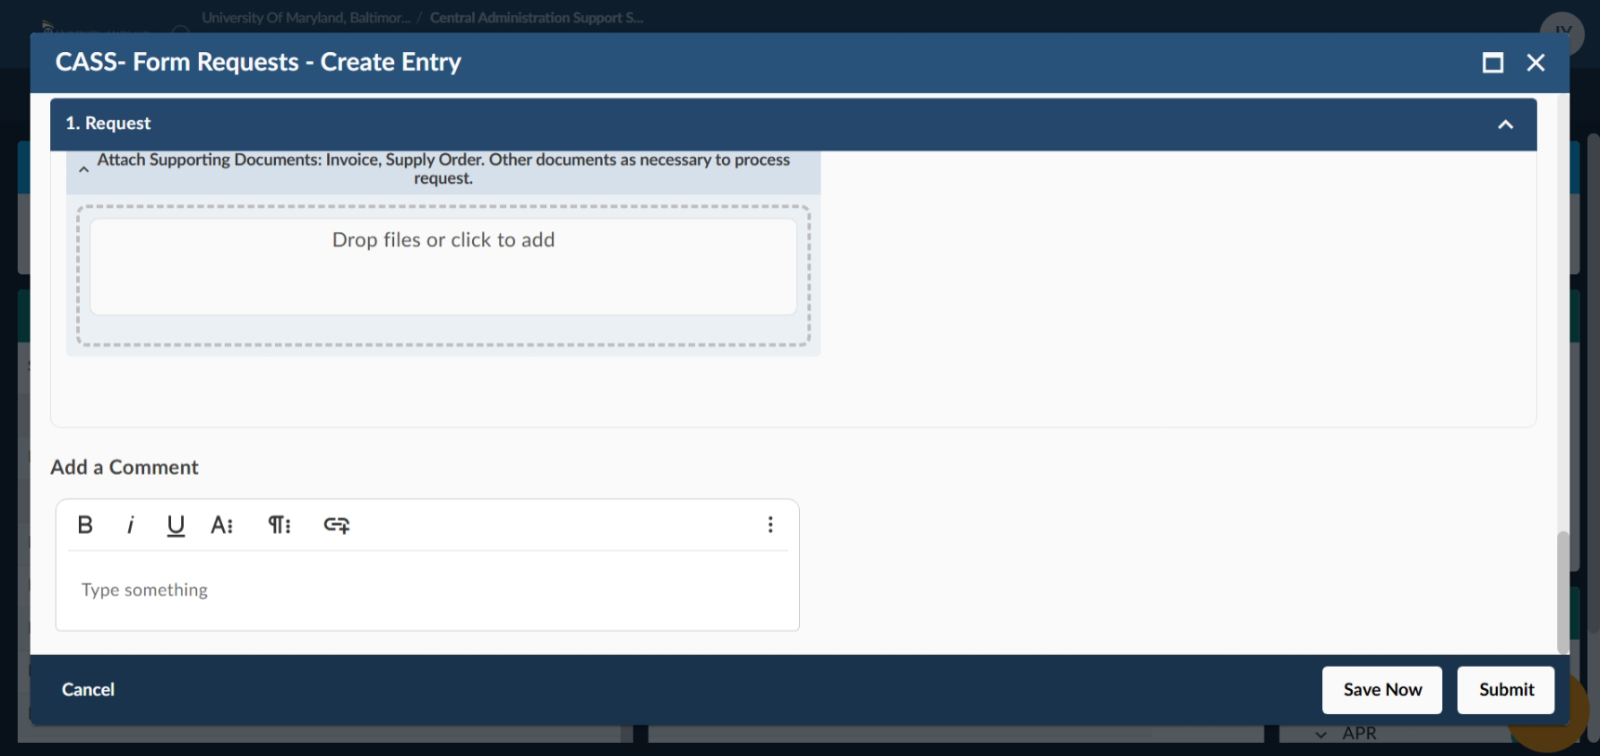

User Dashboard

- Once your request has been submitted, you will be redirected to your User Dashboard.

- The dashboard will display a list of all the requests you have made along with their status.

Additional Notes

- Make sure to check the status of your request from your dashboard. You can see the status of all of your requests by opening your dashboard and then opening the request you want to review.

- If you need to make any changes to your request after submission you can send comments and updates directly through the dashboard by opening your request or you can always reach out to cass@umaryland.edu or our Request Team for assistance.

- Once we have fulfilled your request and close the ticket, you will receive a short survey rating us on our customer service and timeliness.

