Volume Based Billing Events – Credits/Rebills and Cancel/Void Invoice Requests

To void prior invoice OR credit/rebill, please use below instructions and form found on: https://www.umaryland.edu/spac/sponsored-projects-accounting-and-compliance- spac/forms/

- Credit and Rebill Request: Voiding old invoice and creating a new one for the corrected amount.
  - Create volume-based event for the rebill amount and submit form with attachments.
  - Rebill event (new event) information goes in the fields at the top of the form.
  - Please state which invoice number needs to be credited in the comments section of the form.
Example:

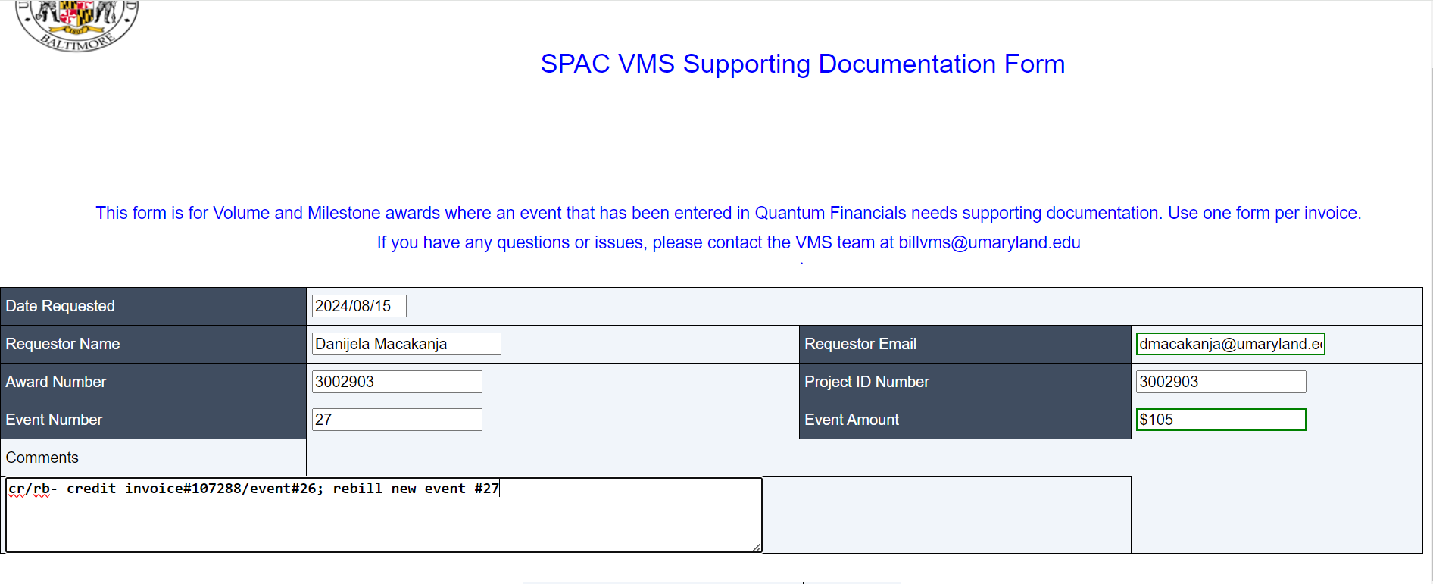
- Cancel/Void Invoice Request: Voiding prior invoice only, and no new invoice needs to be created.
  - No billing event needs to be created in Quantum Financials; only the VMS Supporting Documentation Form needs to be completed.
  - The old event number and invoice details should be inputted in the fields at the top of the form.
  - The “event amount” field should be a negative amount (the same amount as the original invoice, but negative).
  - Include which invoice number to void in the comments.
Example:

SPAC VMS Supporting Documentation Form

This form is for Volume and Milestone awards where an event that has been entered in Quantum Financials needs supporting documentation Use one form per invoice.
If you have any questions or issues, please contact the VMS team at billvms@umaryland.edu

Date Requested Requestor Name
12024100,1s 1
lDanijela Macakanja

Requester Email

ldmacakanja@umaryland.eij

Award Number Event Number
13002480

23
ProJect ID Number Event Amount
130024801

IS-157.17



