Accessing Qualtrics
Qualtrics is an online survey software that allows for easy survey creation. All UMB employees have a Qualtrics account. The Job Aid reviews the steps on how to access Qualtrics for a first time user.
Accessing Qualtrics

- Enter umaryland.qualtrics.com in the address bar of any browser.
- The UMB single sign-on page will appear.
- Enter your UMID and Password.
- You may be prompted to authenticate using DUO
- The following screen will appear:

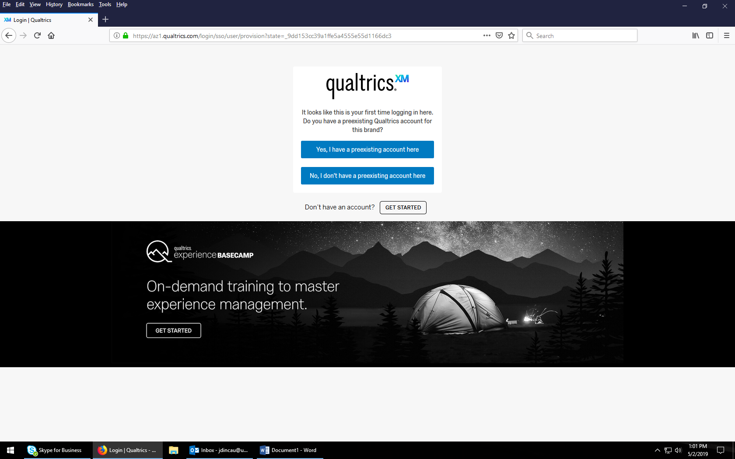

- Click No, I don’t have a preexisting account here.
- The following will appear:
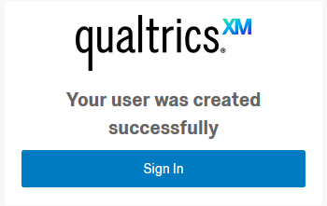
- Click Sign In.
- A Terms of Service screen will appear. Select I agree.

You now have access to Qualtrics. On the pop-up window that appears, select Blank Survey Project to begin using Qualtrics.

