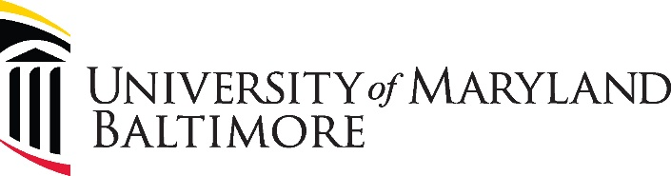

UMB’s Global Program Guiding Principles

Meeting UMB’s Global Program Guiding Principles Outlined in
2020 Internationalization Report
The 2020 UMB Internationalization Report outlined five cross-cutting Guiding Principles that all UMB global programs should embody: social justice-focused, accessible, ethical, innovative, and sustainable.
The following checklist – which may also be considered a reflection of best practices – emerged from internationalization reports from each of the seven UMB schools. Not every global program can – or is intended to – fit all the criteria outlined below. Rather, this checklist is a resource to guide program development.

Social Justice Focused Programs
A social justice-focused program at UMB is:
- Focused on community-based collaboration
- Accessible (see below)
- Ethical (see below)
- Not violative of human rights
- Accountable to those we serve
- Relationship-driven and community-driven
- Not exploitive of vulnerable populations
- Sensitive to power dynamics and vulnerability, especially in medical settings
- Respectful of contributions of all
And provides experiences that emphasize collaborative skills, active listening by all, cultural humility, and resilience.

Accessible Global Programs
An accessible global program creates opportunities for students regardless of their financial means; UMB local community members; students and postdocs to get involved in research and develop new lines of research and inquiry from existing data; and international partners.
It grows existing partnerships and makes them more accessible to students and faculty on all sides of the partnership. It is also:
- Designed from the outset to grow beyond initial formation
- Available to all students without regard to their financial circumstances
- Planned transparently so that students understand how the cost of the program was determined
Provides opportunities for global learning in Baltimore that are:
- Convenient, easy to register, easy to find, safe, meet the students schedule, well-designed for student schedules, well-advertised
- In both elective and required courses
- Threaded throughout the curriculum, not just in global pathways
- Available to a majority of students in a majority of schools
And finally, it involves community members in a meaningful way and communicates the value of the program to students.

Ethical Global Programs
An ethical global program is:
- Mutually beneficial for all partners
- Not violative of human rights
- Accountable to those we serve
- Relationship-driven and community-driven
- Enduring and sustainable
- Not exploitive of vulnerable populations
- Conducted with pre-departure training in appropriate licensure rules, ethical photography, country specific cultural competence
- Sensitive to power dynamics and vulnerability, especially in medical settings
- Respectful of contributions of all professions
It abides by all relevant rules and regulations of all partners and UMB commitments, acting in a manner that merits trust and confidence. It works toward high quality and excellence, promotes diversity and inclusion, demonstrates an appropriate level of transparency and exposes real or potential conflicts of interest, and serves the well-being of communities.
An ethical global program reflects UMB core values, adheres to international and local human subjects research rules, does not impose burdens on communities, and ensures community and individual consent for all activities.
It builds meaningful and trusting relationships in communities before activities/research commence, as well as partnerships with trusted community organizations.
It facilitates bi-directional learning, positions global partners as content experts, includes education regarding meaningful understanding of history of local communities and structures that shape health and well-being, and supports communication and teamwork between professions.

Innovative Global Programs
An innovative global program promotes new ways of teaching, learning, researching, and addressing long-term or intractable concerns/problems. It creates new academic relationships, models of collaboration, and interprofessional global programs
It brings together expertise and knowledge that does not yet exist on campus and some global solutions from overseas.
It studies a novel question, approach, or intervention, or an out-of-the-box solution. It fosters new use of technology, pedagogical paradigms, pedagogy, and learning outcomes.
An innovative global program embraces collaboration with a diverse student body as well as the local community. It integrates interprofessional learning competencies into global education and expands interprofessional education beyond the clinical care context.

Sustainable Global Programs
A sustainable global program creates long term partnerships that grow and expand over time, multiple linkages to a single international site, and dense networks. It fosters multiple professional school links with a single international site and long-term commitments.
A sustainable global program values:
- Clearly articulated parameters outlined in mutually beneficial MOUs
- Bi-directional relationships both electronically and in person
- Appropriate partners rooted in similar goals
- Shared funding with partners
- Shared investment with partners
- Shared research, publications, and scholarship opportunities

