Human Research Protections Program
Emergency Preparedness Plan
2025

Disclaimer
This plan outlines a flexible, base framework for UMB HRPP general response to an emergency. However, each emergency is unique and can entail unforeseen circumstances. Therefore, nothing in this plan prevents UMB and the UMB HRPP from taking actions it deems proper for responding to the emergency, even they differ or diverge from what is contained in the plan.

Revisions
The HRPP evaluates its emergency plan at least annually, with a record of revisions below.
Date of Review | Review By | Summary
2025 | HRPP, OEM | 2025 Version

Purpose
This document identifies how the rights and welfare of research participants are protected during an emergency involving the University of Maryland, Baltimore (UMB). It establishes the process for initiating a response to an emergency/disaster situation impacting the Human Research Protections Program (HRPP) or HRPP operations.

HRPP Emergency Response Policy
HRPP leadership defers to institution-wide disaster and emergency response planning and limits HRPP-specific disaster and emergency response planning only to those areas of operations or human research protections not otherwise covered by institution-level plans. This HRPP Emergency Preparedness plan serves as an Annex to the UMB Emergency Operations Plan (EOP). The EOP is an organized framework for planning and delivery of emergency management services to the UMB community. UMB disaster and emergency response planning include the following:
Table 1: Scope of Emergency Plans
Circumstances | Applicable Plan | Scope of Plan | Expectations for HRPP
Imminent life safety risk | Occupant Emergency Plan (OEP) | Institution-led (Building-specific) | Complete EP Training to become familiar with OEP
Emergency risk or impact (see EOP Section 1.2) | Emergency Operations Plan (EOP) | Institution-wide | Coordinate through school/dept EMT member
Essential processes have been disrupted | Continuity of Operations (COOP) Plan | Institution-supported (School/dept-specific) | Participate in school/dept-specific COOP Plan creation
Rights or welfare of research participants at risk in an emergency | HRPP Emergency Preparedness Plan | HRPP | Annually review the plan; Train applicable individuals

Roles and Responsibilities
The table below illustrates the roles and responsibilities for emergency preparedness at UMB.
Table 2: Emergency Preparedness Roles
Role | Position | Name
Designate an individual to oversees campus emergency planning. | President | Dr. Bruce Jarrell
Oversee campus emergency planning, prevention, preparedness, response, recovery, continuity of operations, and safety and security. | Senior Vice President and Chief Business and Finance Officer, Administration and Finance | Dr. Dawn Rhodes
Administer emergency planning, preparedness, response, recovery, and continuity of operations | Executive Director, Office of Emergency Management | Chris Stanton
Ensure participation in trainings, exercises, and real-world response and recovery efforts. | Emergency Management Team (EMT) | See EMT Roster online
Coordinate development of and training on the HRPP Emergency Preparedness Plan | Assistant Vice President, Research Compliance | Dr. Julie Doherty
Implement the HRPP Emergency Preparedness Plan | Vice President & Chief Accountability Officer Institutional Official (IO) | Dr. Susan C. Buskirk
Complete Emergency Preparedness Training  https://www.umaryland.edu/emergency/training/ | HRPP positions | As determined.

Threats and Hazards
UMB maintains a Threat and Hazard Impact Risk Assessment (THIRA). The THIRA assess the vulnerability, preparedness, probability, and magnitude of a variety of natural, man-made, and technological threats and hazards that could impact life safety, property, the environment, and continuity of operations. The THIRA identifies the “top” threat/hazard types, shown in Table 3. An Emergency Reference Guide is available online and posted near egress points in UMB buildings, which provide “just-in-time” guidance for occupants based on specific hazards.
Table 3: UMB Top Threats and Hazards
Hazard | Hazard Context
Utility Outage | Disruption of utility systems and / or commodities that support the UMB campus, to include potable water, gas and electrical power, HVAC, and sewage removal.
Flooding | Rainstorms over the campus where drainage cannot accommodate runoff, and coastal storms that pass over Baltimore City producing storm surge and/or rainfall in a short timeframe.
Cyber Disruption | Temporary or permanent loss of IT service or data due to human error, intentional cyber-attack, or physical damage from other hazards.
Hazardous Materials | An uncontrolled release of a chemical, biological, or radiological agent within the UMB Clery boundary with the potential to harm UMB people, property, environment, and/or reputation.
Infectious  Disease | A sudden increase in cases of an infectious disease that poses a risk to the health and safety of UMB personnel or disruption to continuity of operations.
Severe Winter Weather | Precipitation, such as freezing rain, snow, sleet, and ice that result in unsafe conditions on the UMB campus, have the potential to damage UMB property, or disrupt campus operations.
Active Assailant | Individual(s) actively engaged killing or attempting to kill people in a populated area within UMB’s Clery boundary.

Emergency Preparedness Actions
The following actions prepare IRB members and staff, researchers and research staff, and other persons in the HRPP to be knowledgeable about UMBs response plans and expectations during emergencies:

All persons in the HRPP:

Verify contact information is correct in UMB Alerts (https://www.umaryland.edu/emergency/alerts/)

Read Occupant Emergency Plan for the building(s) where your human research is occurring (https://www.umaryland.edu/emergency/occupant-emergency-plans/)

Complete Emergency Preparedness Training (in-person and web-based course options) (https://www.umaryland.edu/emergency/training/)

IRB members and researchers:

Save contact information for your appropriate Emergency Management Team (EMT) representative (https://www.umaryland.edu/emergency/oem/emergency-management-team/)

Inquire with your EMT representative about the scope and applicability of your school/department COOP Plan. Consider using the e-Tool to create a COOP Plan specific to the research location or activity.

Direct research participants to be familiar with the Emergency Reference Guide (https://www.umaryland.edu/media/umb/emergency-management/EMERGENCY-FLIER2022.pdf)

Inform research participants they can enroll in UMB Alerts (https://www.umaryland.edu/emergency/alerts/).

HRPP Emergency Procedures
HRPP personnel are expected to be familiar and perform the following procedures.

Emergency Notification
- Individuals involved in Human Research, including research participants may become aware of an emergency through the following means:
  - Direct observation
  - Building-specific alarm (e.g., fire alarm or public address system)
  - Person of authority (e.g., UMB Police officer)
  - UMB Alerts
    - UMB Alerts is the institution’s primary means of providing broad emergency notification.
    - UMB students and employees are directly enrolled in UMB Alerts
    - At this website: https://www.umaryland.edu/emergency/alerts/
      - Research participants may enroll in UMB Alerts and/or UMMC alerts.
      - UMB students and employees may enroll in UMMC alerts.

If an emergency/disaster is imminent or has occurred, determine the appropriate response.
- If imminent risk to life safety or property, call 911 and act according to the figure below:
Figure 1: Imminent Risk to Life Safety
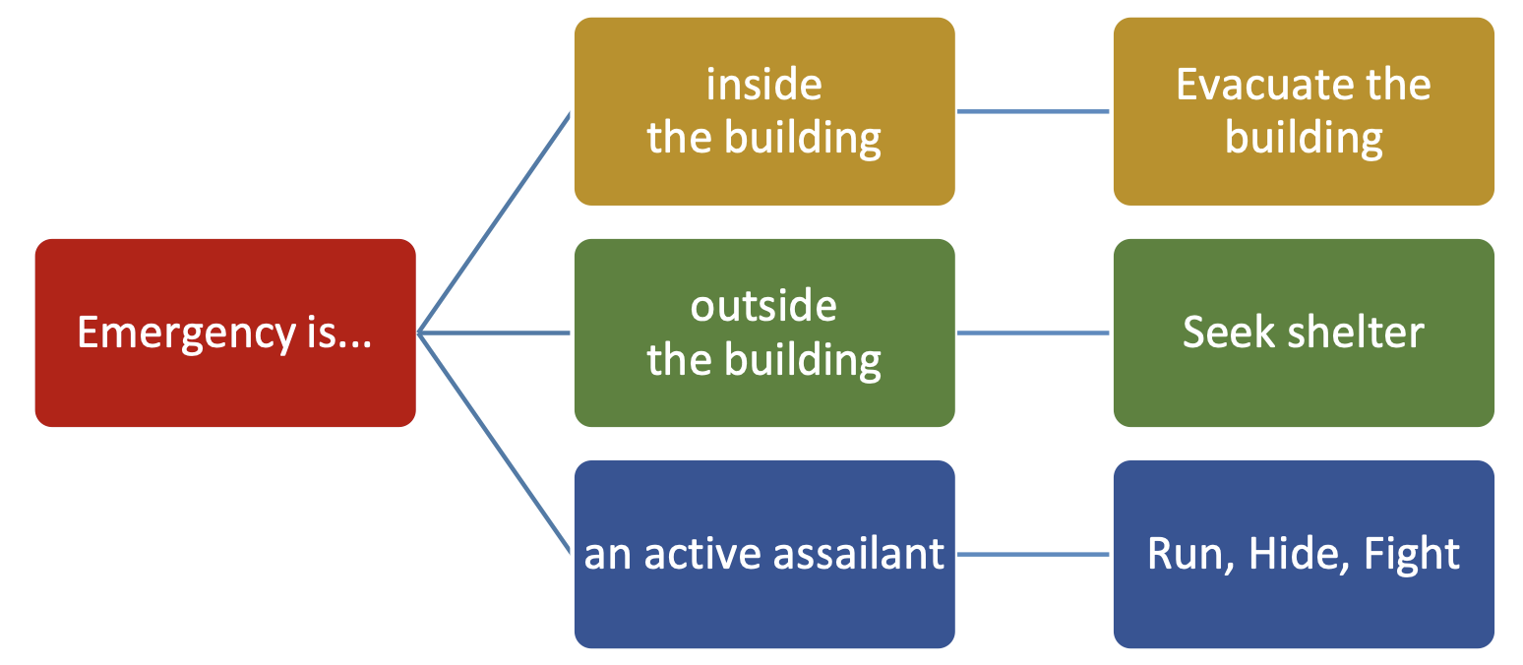
- If normal day-to-day procedures and resources are insufficient to manage the response and recovery from a hazard which poses an immediate risk or impact to the following vital services, contact your EMT member (https://www.umaryland.edu/emergency/oem/emergency-management-team/):
  - Life, safety, and health of UMB students, staff, and faculty engaged in institutional activities;
  - Protection of UMB owned and controlled property;
  - Protection of the environment at risk from an emergency impacting UMB;
  - Continuity and restoration of essential utilities to UMB owned and controlled property;
  - Continuity and restoration of UMB essential functions and programs;
  - Continuity of the good institutional reputation of UMB; or
  - Coordination among appropriate stakeholders, including with local community and state partners who request mutual aid assistance from UMB.
- If essential processes have been impacted, implement the school/dept. COOP Plan, and notify the Emergency Management Duty Officer at 410-706-8888.
- Contact the IO/OO to provide notice on the risk/impact from an emergency. Determine whether there are new or revised institution level emergency related guidance/direction. If yes, proceed in accordance with those plans and determine whether further contact or notification of the human research community is necessary.

Assess whether the emergency/disaster could impact HRPP continuity operations by referring to school/dept COOP Plan. If no school/dept. COOP Plan, follow the steps below:
- If the current or anticipated emergency/disaster will prevent any upcoming IRB meetings from properly convening, take the following actions:
  - Work with the IRB Manager and IRB Chair on rescheduling the meeting. Follow HRP-040 - SOP - IRB Meeting Preparation to confirm quorum and availability of IRB members.
  - If currently approved Human Research has or will expire prior to IRB review due to the IRB meeting cancelation/rescheduling, follow HRP-063 - SOP - Expiration of IRB Approval.
- If IRB staff will be unable to complete their protocol processing and review responsibilities during the emergency/disaster, or if capacity will be limited for a period:
  - Work with the staff to use any available capacity to prioritize protocol processing, pre-review, and review of continuing review submissions.
  - If currently approved Human Research has or will expire prior to IRB review due to IRB office capacity limitations, follow HRP-063 - SOP - Expiration of IRB Approval.
  - Work with the IO/OO to notify the research community of the IRB Office’s limited capacity to process and review submissions.
  - When the emergency/disaster no longer presents a limitation to IRB Office functions, work with the IO/OO to notify the IRB members and staff and research community that normal business operations have resumed.
- If impact to local HRPP operations will be extensive or long-lasting, determine whether reliance on an external IRB(s) is required.
  - If reliance on one or more external IRBs is required and the necessary reliance agreements are not currently in place, work with the IO/OO to identify appropriate candidates for external IRB reliance and follow HRP-801 - SOP - Establishing Authorization Agreements.
- If data or records (paper or electronic) are unavailable during the current or anticipated emergency/disaster, consult with local IT support and or electronic system vendors to implement alternative procedures to access data/backup data.

Assess whether the emergency/disaster could necessitate additional flexibility in IRB review processes. If yes:
- Review HRP-352 - WORKSHEET - Additional Emergency-Disaster Review Considerations with the IRB Chair(s) and staff in advance of upcoming IRB meetings.
- Communicate to IRB Members (including Designated Reviewers performing non-committee reviews) that the additional considerations in the worksheet may be incorporated into IRB reviews where appropriate to maximize regulatory flexibility while continuing to assure research subject safety during the emergency/disaster.
- Determine whether additional communications to the research community are necessary to inform investigators of any additional measures the IRB will take to maximize regulatory flexibility during the emergency/disaster and notify the community as appropriate.

Assess whether the emergency/disaster could impact some or all investigators’ ability to conduct Human Research. If yes:
- Notify the research community of the need for protocol-specific emergency/disaster risk mitigation planning.
- Which could in turn impact research, develop guidance for researchers that clarify what does and does not require IRB review (e.g., screening procedures mandated by the health care system in which a clinical trial is being conducted).
- When the emergency/disaster no longer presents a limitation to Human Research activities, work with the IO/OO to notify the research community that normal business operations have resumed.

Evaluate whether the nature of the emergency/disaster may pose additional threats or risk to specific aspects of the institutions research activities or facilities.
- Seek guidance from the UMB Unified Command (contact via dept/school EMT member) of whether cascading hazards (e.g., man-made disasters, industrial accidents, or terrorist threats) could potentially impact some chemical, biological, or radiologic facilities to a greater extent than other facilities.
- If yes, and if broader UMB institution-level emergency/disaster preparedness measures do not already address these specific activities or facilities, work with the IO/OO and appropriate institutional leadership to escalate and address any additional threats or risks.

Materials
- HRP-060 - SOP - Annual Evaluations of the HRPP
- HRP-101 - HUMAN RESEARCH PROTECTION PROGRAM PLAN
- HRP-542 - Implementation of HRPP Emergency-Disaster Response Plan
- HRP-801 - SOP - Establishing Authorization Agreements

References
- AAHRPP Element I.1.H
- AAHRPP Tip Sheet: Emergency Preparedness and Response
- USM Policy VI-13.00 https://www.usmd.edu/regents/bylaws/SectionVI/VI1300.pdf
- UMB Emergency Operations Plan https://www.umaryland.edu/emergency/
- UMB Continuity of Operations Program https://www.umaryland.edu/emergency/continuity-of-operations/
- UMB Occupant Emergency Program https://www.umaryland.edu/emergency/occupant-emergency-plans/
- UMB Emergency Reference Guide https://www.umaryland.edu/media/umb/emergency-management/EMERGENCY-FLIER2022.pdf
- UMMS/UMMC Emergency Preparedness procedures

