EpicCare Link Workflows for Study Monitors
FACILITY: | UMMS
ROLE: | Research TEAM

Today, Study monitors are able to access any patients thru EpicCare Link thru Portfolio MD. This change will restrict all Study Monitors to only be able to access patients that are related to their specific studies and have been manually released by Research Coordinators to specified study team member/monitor.

What’s Changed?
All Study Monitors will be able to access patients that are related to their specific studies and have been manually released by Research Coordinators to specified study team member/monitor.

Study Coordinator logs in to EPIC Portfolio
Search for My Reports 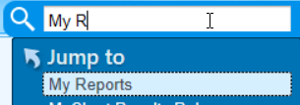
In the search window right below Library type Find Patients Associated with Research Studies - Per Study and click Search:

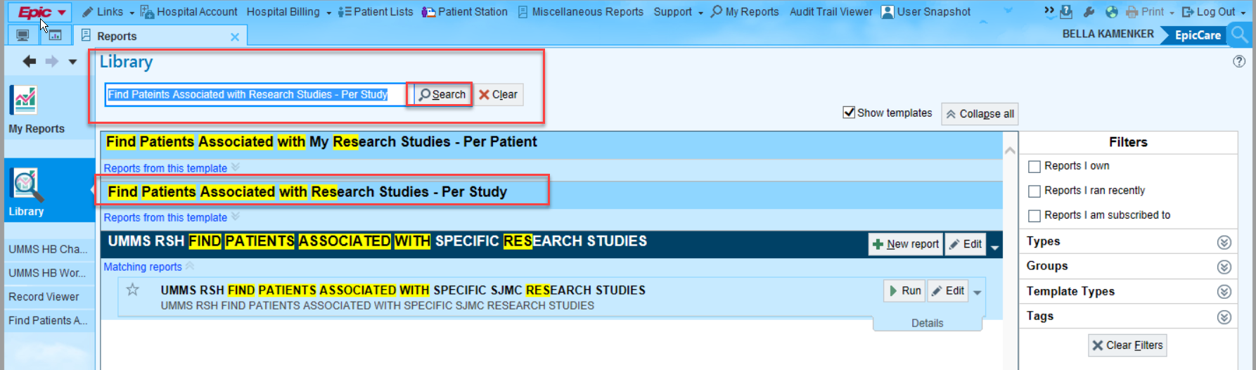
Click on and run it 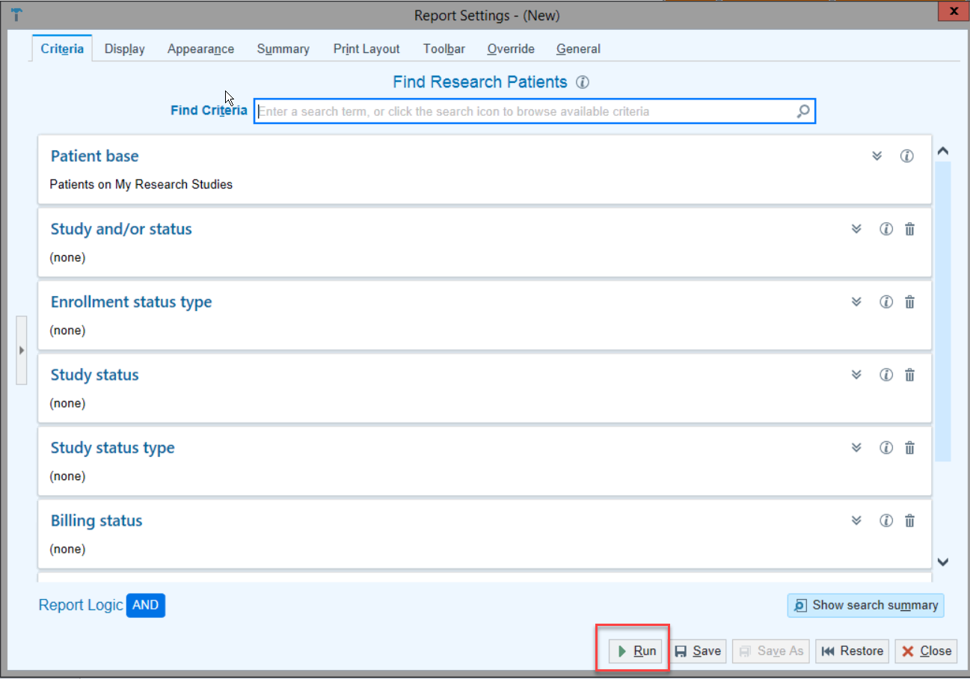 without changing any of the parameters.

’

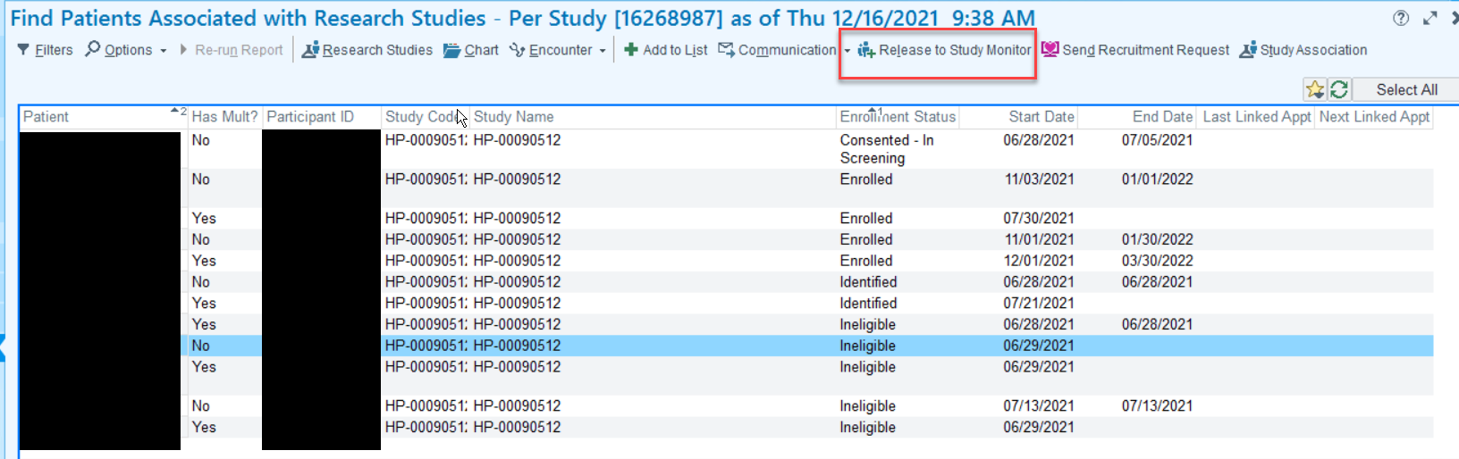
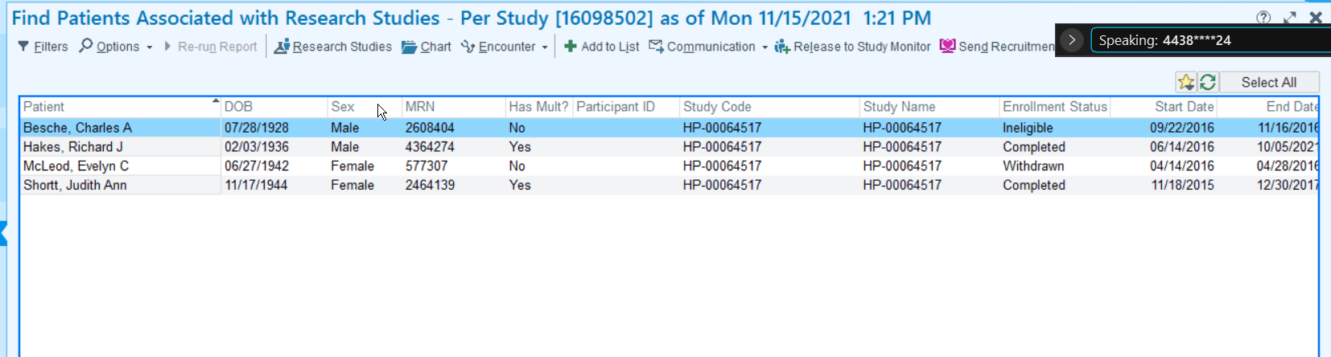
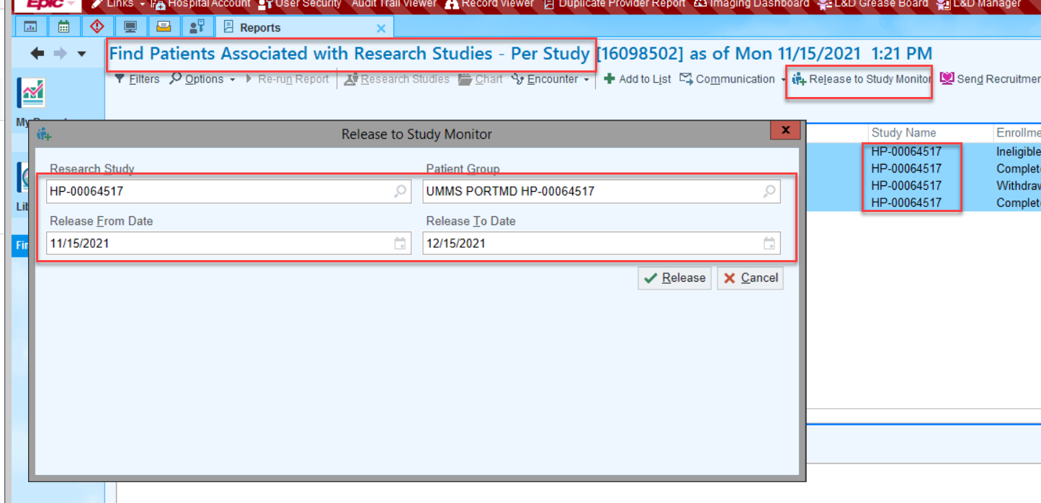

Portfolio MD
https://portfoliomd.umm.edu/EpicLink/common/epic_login.asp
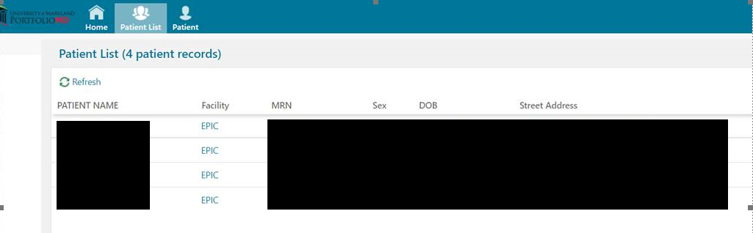
Note: 742378 - EpicCare Link Workflows for Study Monitors

