Kuali Research Dashboard
The Kuali Research Dashboard is the updated user interface for KR, which provides new tools to manage and search for relevant records based on your own preferences and action list. The Dashboard provides access to all of the original full search tools and common menu items for each module.

Dashboard Home Page
Log in as usual to Kuali Research.
The system will display the Dashboard Home Page, which contains Dashboard cards and an expandable navigation bar on the left side that allows users to access various resources in Kuali Research.
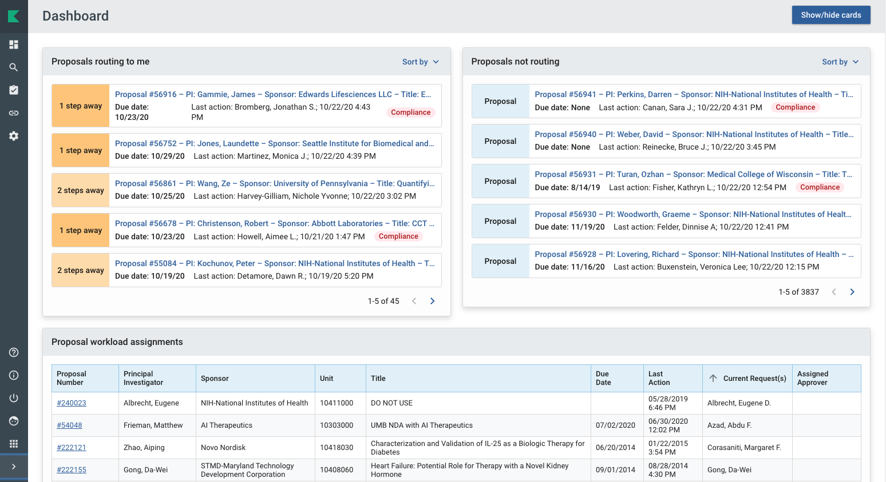

Expand/Collapse Menu
If the left navigation menu is “collapsed” as in the illustration above, go to the VERY BOTTOM LEFT and use the > to open the left navigation of the dashboard and see the descriptions.
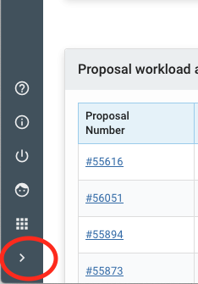
When you familiarize yourself with the Dashboard Home page, if you would like more screen space you may choose to collapse the bar and simply show the icons.

Dashboard Cards
There are three dashboard cards that all relate to Proposal Development. Within each card, you may click on an item to open the record. See the Dashboard Cards page for more detailed information on cards.

Show/Hide Cards
The Show/Hide Cards button in the upper right corner allows you to select which cards you want to show or hide.

Left Navigation Menu Items
The Navigation Bar on the left allows you to navigate to various sections of Kuali Research. SPA and Dean’s Office Users may see additional menu items (Reports and/or Configuration), which are for “back office use only”.

 | Returns to the Dashboard Home page.
 | Search provides a new, all-in-one comprehensive search of Awards, Institute Proposals, Subawards, Development Proposals and other records.
 | Displays the most common tasks for each module in KR, which includes accessing full searches for each module, creating new records, and has a link to your action list.
 | Displays links to various lookup tables for sponsors, organizations, and address book records as well as for commons tasks.
Opens a new window with a generic help guide. Instead, please use the resources at:
https://www.umaryland.edu/kualicoeus/user-resources-and-help/
 | Lists the current version of Kuali Research.
 | Allows you to log out of Kuali Research.
 | Displays the current user. If you click on this accidentally it will open up a new browser tab with your user information. You may simply close this tab and return back to your previous tab. You may also return back to Kuali Research by clicking on Switch Apps > Research Home.
 | Allows you to switch to different apps in the Kuali Suite. Please only use the Research Home and return to Kuali Research.
 | Collapse Menu allows you to expand and collapse the navigation bar. When you expand you can see descriptions for each icon and when you collapse the bar you only see the icons for each item.

