Search Records
The Search Records page provides a comprehensive all-in-one search of Awards, Institute Proposals, Subawards, Development Proposals, and other records based on your search criteria. It is most useful when you need to search across multiple document types (Award, Institute Proposal, Subaward, etc.).
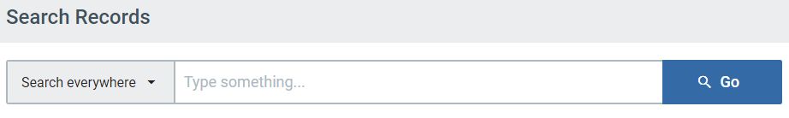
NOTE: The traditional full search tools are still available and useful when you want to search within each module (Award, Institutional Proposal, Subaward, Proposal Development, etc.). To utilize the full search tools, navigate to the Common Tasks page, and click on the search option under the appropriate module.
How do I search?
Type in your search criteria and click “Go” or press enter to initiate a search.
- Type in one word or a combination of words.
- Use the search operator “-” to remove specific values from your results.
- Use double quotes for phrases or strings of text (e.g., “apple tree,” “301000-00001”) but not with search operators.
- You cannot search multiple values of the same item simultaneously (e.g., acct 30011571 and acct 10023368).
- Keep in mind, when performing a search, it may return results that contain the value. For example, searching 301000 and will match with everything from lead units 12301000, 04301000 and others. It might also pick up 301000 in a title, document number, or other field.
Below are some example of simple searches:
Doing a broad search by name may produce too many results.
You can add the document type of the desired records in the search to help limit your results by module.
Try adding additional search terms in phrases and excluding what you don’t want with a “-”
Search for award numbers using quotes (otherwise, the search will misinterpret the “-”).
Search by the first 6 characters of an award family to return parent and children (-00001, -00002, etc.)
Searching by account number will return and awards and subawards funded by that account number.

Narrow Search by category
Narrow your searches by clicking on the “Search everywhere” drop-down to see a list of all the available searchable categories and select one. This will allow you to target which columns you’d like to search within using specific values in instead of searching across all columns. If you are getting lots of unwanted results, using the category limits here is highly recommended.
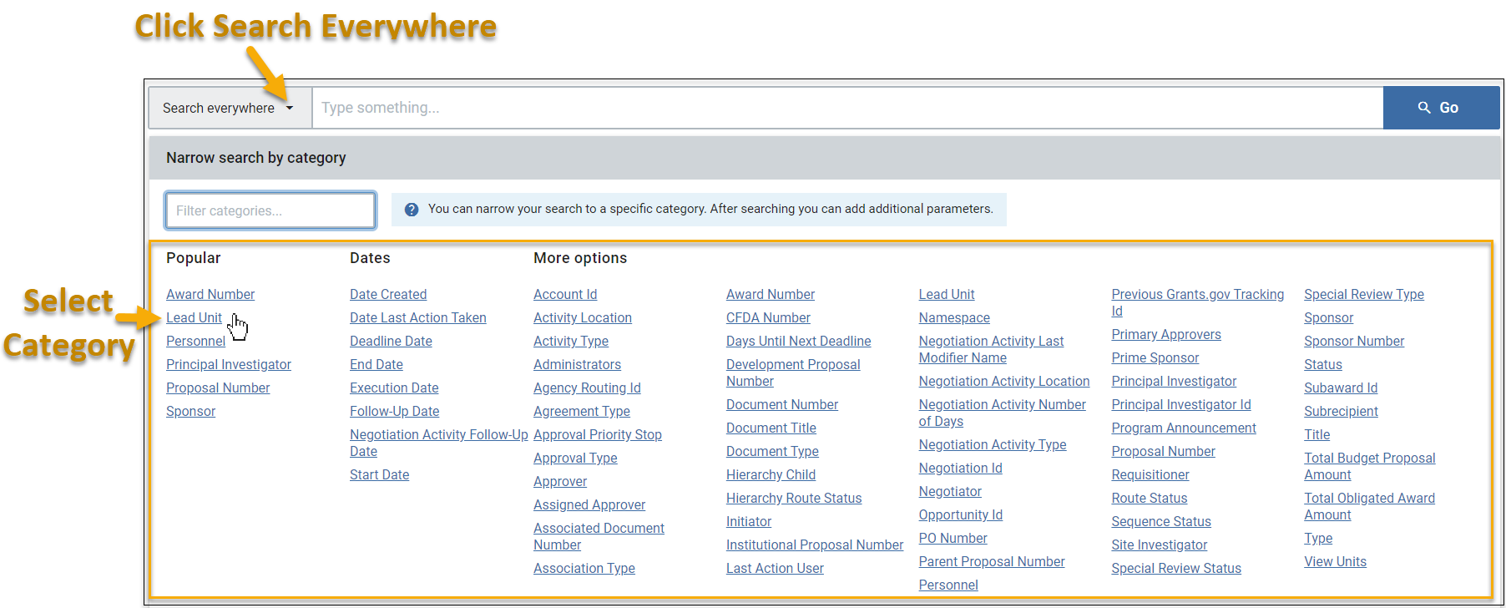
Once you choose the category, type in the desired search value then, click enter or “Go.”
You will now see that the search variable has been slotted below the search bar.
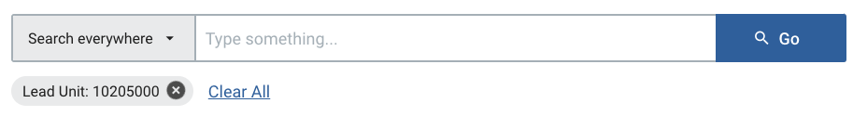
If you want, you may continue to narrow down your results further by adding additional categories. Just repeat the process of selecting a category, entering the desired value, and clicking “Go” or enter.
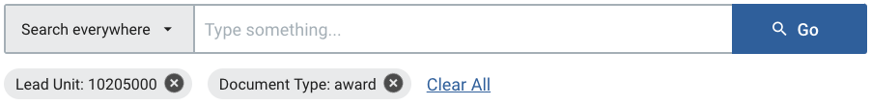
NOTE: If you’d rather not look through the categories, you may also filter it by typing keywords.
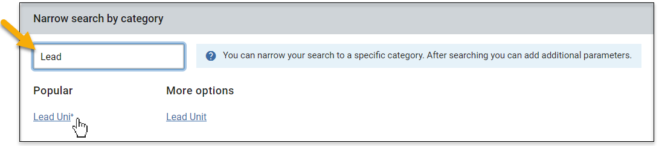

Show/Hide Columns
After you’ve performed a search, you will see a “Show/Hide Columns” button available, which allows you to select which columns you want to be visible in your search results. The button is located on the far right of the search results screen and appears only after your initial search results are displayed.

Adding Columns  If you check a column checkbox, it will be visible in your search results. By default, “Remember my choices” at the bottom of the list is checked, which will save the columns displayed but is limited to the browser and computer you are using.  You may manually reorder your results by clicking on the six dots by a column and dragging and dropping to the desired location. | 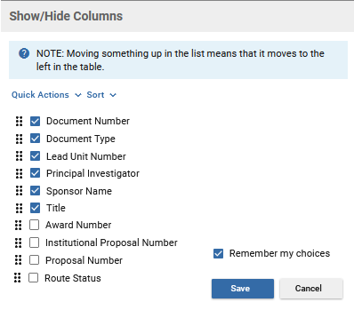
Quick Actions  If you click on “Quick Actions,” you can select or deselect all columns or restore the original defaults. | 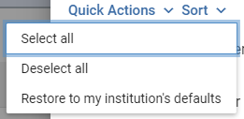
Sort Drop-Down  Clicking on “Sort” allows you to move all the checked columns together at the top for readability or sort A-Z, Z-A. The higher a column is on the list, the more leftmost it will be in your search results. | 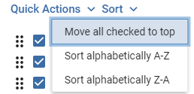

Multiple Rows for the Same Institute Proposal, Award, or Subaward
As SPA makes updates to records throughout the day on Institute Proposals, Awards, and Subawards your search results may show the same item twice in two unique situations. Below are a few tips to help you decide which one would be best to view, but if you’re not sure, you can always do a full search in the appropriate module by visiting the Common Tasks page, which will show one result per record.

Currently Being Updated
If SPA is in the process of updating a record, you will see that one item has a Route Status of “FINAL” and one item has “SAVED.” You will want to view the current record in a “FINAL” route status in this case. (You can add Route Status as a column in Show/Hide Columns above your search results)
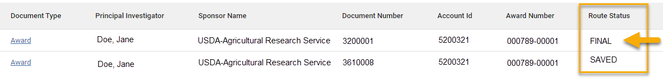

Recently Updated and Finalized that Day
If SPA just recently updated a record that day, you may see two results that both have a “FINAL” Route Status. In this situation, you will want to open the higher of the Document Numbers you see listed here. NOTE: This is a temporary artifact after SPA finalizes an update. A nightly process cleans these duplicate entries up, and the next day there will be only one result instead of two.
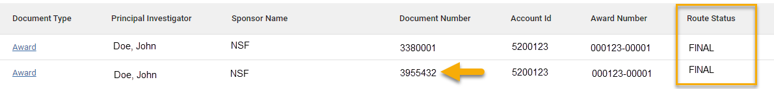

Search Tips!
- Use the “Search Everywhere” dropdown to limit your results by category if too many items are listed. Narrowing down results with this flexible tool will allow you to perform targeted searches.
- In your search results, click on the Column Headers to sort any column in A-Z or Z-A order.
- Based on what your criteria are, you may want to change the columns that are displayed in your results to better suit your returned results via the Show/Hide Columns button.
- Use multiple words or a phrase with quotes in the “Search Everywhere” field to narrow your search down as needed. Phrases with quotations cannot be used in Category limits.
- Using the “*” as a wildcard to search is superfluous. You can enter a short string to simulate the same type of query within the search bar OR in a category. For example, searching “cano” will return results for “Canon”, “canopies”, “Canonical”, etc.
- Search results do not include canceled development proposals. Use the Common Tasks page to view the Proposal Development Full Search screen and retrieve a proposal that was canceled.
- When searching by an award number, use the first six digits to pull all awards within a family or enter an award number in quotes to pull results based on that single award.

Column Suggestions
After performing searches, you may feel that you are missing some key fields that would help you differentiate records from each other, or you may find it challenging to understand why you are getting certain results. Adding more Columns to display in your search results with the “Show/Hide Columns” tool can help in successfully navigating your returned results. We have listed some suggestions below based on the document type. You can mix and match or use any of the other available fields to suit your needs better.
Awards
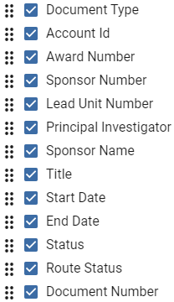 | NOTE: Account Id is the Project ID (Quantum)  NOTE: Sponsor Number is the Sponsor Award ID.

Institute Proposals
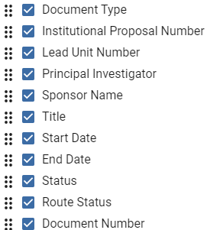
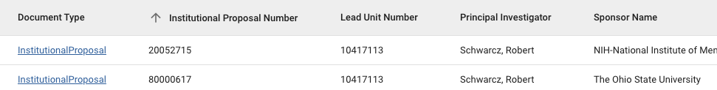

Development Proposals
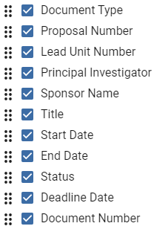
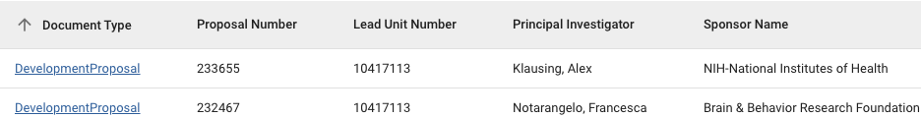

Subawards
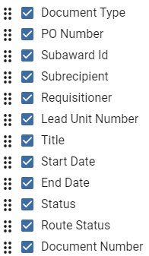
NOTE: Requisitioner is the UMB PI
