Creating a “high-level” budget in Kuali Research
NIH MODULAR BUDGETS

A “high-level” budget has annual direct and indirect (F&A) costs for a proposal with little to no budget detail. In certain situations, you may enter a high-level proposal budget in Kuali Research. You have the option to enter a high-level budget:

- If you are entering budget detail in a sponsor submission system such as Workspace, ASSIST, Fastlane
- If you are creating an NIH modular budget
- If you are creating a clinical trial budget on a separate spreadsheet
- For some other non-Federal sponsor submissions, with SPA approval

For NIH Modular budgets:

Always start with a detailed budget. No exceptions.

Budget Entry

Click +Add Budget
Enter a Budget Name
Select “Start a detailed budget”
Respond “Yes” to the question “Will this be a modular budget?”
Click Create Budget
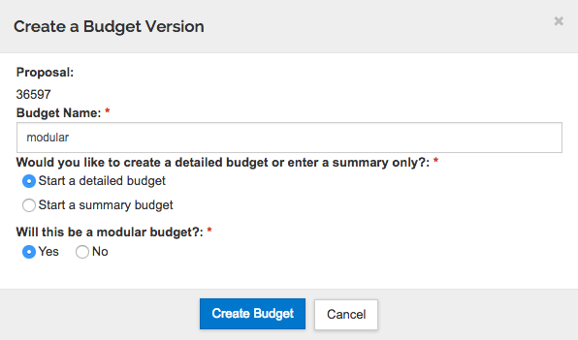

KR will bring up the Project Personnel screen

Select Budget settings from the top menu bar

In the Budget Settings window,
- On/Off Campus: DEFAULT is On Campus. Change if needed.
- F&A Rates: For NIH grants, select “MTDC On- or Off-Adjacent”. The F&A Rate Type and the Unrecovered F&A Rate Type should match. Change both settings if a change is needed.
- Make sure the Modular Budget checkbox is checked.
- Uncheck the box next to “Submit Cost Sharing”.
- Exclude Subcontract F&A from Direct Cost Limit: This box will be checked by default for Modular budgets.
- Click “Apply Changes”.

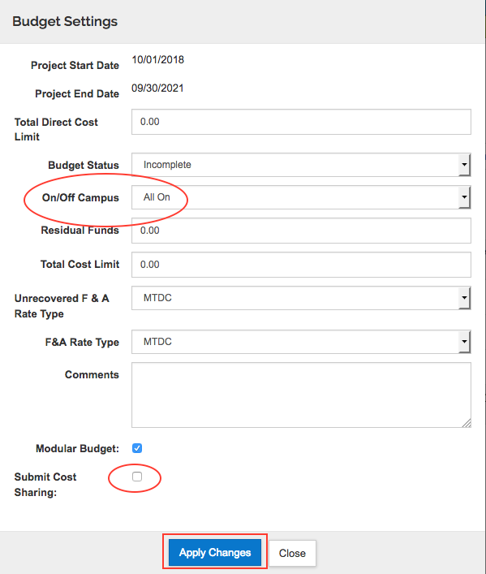

Using the left navigation menu, go to the Non-Personnel Costs section of the budget.

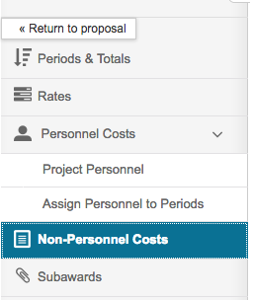

Click Assign Non-Personnel
- In the Add Assigned Non-Personnel window, select:
- Category Type = Other Direct
- Category = Other Operating Expenses
- Object Code Name = Direct Costs except subs/equipment

- In the Total Base Cost field, enter the amount that represents the year 1 direct costs for the project, minus any equipment (>$5000 acquisition cost) and minus the total amount of any subawards.

Click Add Non-Personnel Item to 1
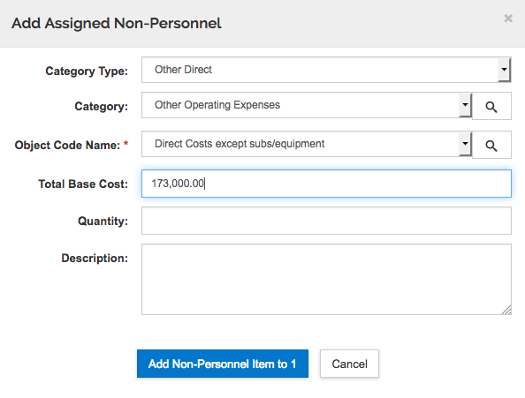

If the budget includes equipment, click Assign Non-Personnel and add the equipment as a separate line item.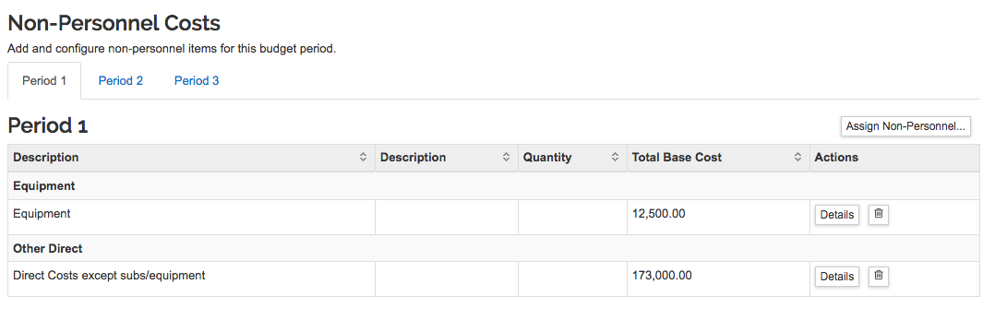

From the top menu bar, select Autocalculate to generate all budget years, or manually enter all budget years at this time, omitting any subaward costs.

If your budget does not include any subaward, skip to the Sync Modular Budget instructions (below).

If your budget includes a subaward:
Save and continue or navigate to the Subaward section.
Upload a completed subaward budget form following standard procedures (http://www.umaryland.edu/media/umb/ord/documents/kc/Upload-Subaward-Budget.docx).

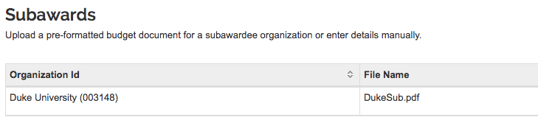

Sync Modular Budget

Save and navigate to the Modular Budget section. Click the LEFT side of the Modular option (✓ Modular) to open the modular budget in the same window/tab. Click the RIGHT side of the Modular option (the little box) to open the modular budget in a new tab.

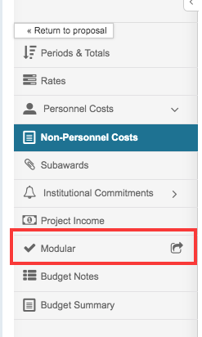

The modular budget syncs on opening. It tells you when it was last synced, and you can manually sync using the Sync button in the upper right corner of the screen.
- Note that you can collapse and re-open the left column (click the arrow/text in the lower left corner)
- If you have opened your modular budget in a new tab, simply close the tab when finished.
- If you have opened your modular budget within your proposal window/tab, use “Go to detailed budget” (left navigation menu) to return to your budget and your proposal.
- Note that you can “Go to proposal” directly from the modular budget, but in the proposal, click “Edit” at the bottom of the screen to continue editing.
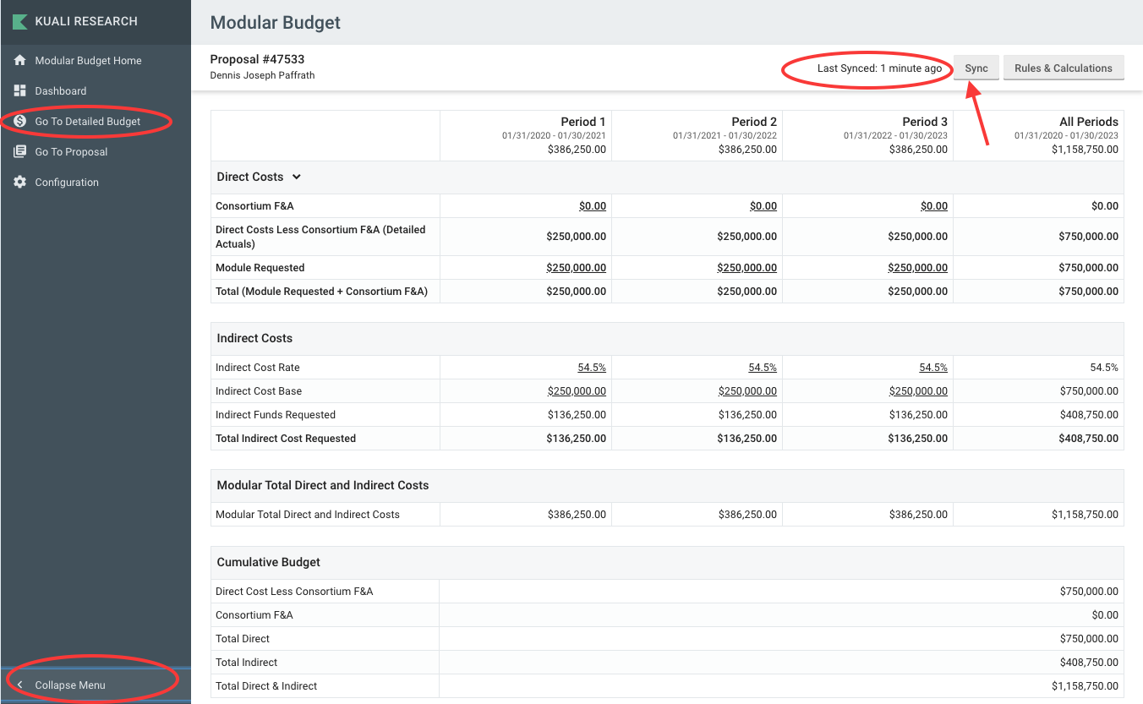

To edit the number of modules requested, double-click in the Direct Costs Module Requested cell for the appropriate period, and enter the update. Respond “yes” to the dialogue pop-up warning to keep the edited amount.
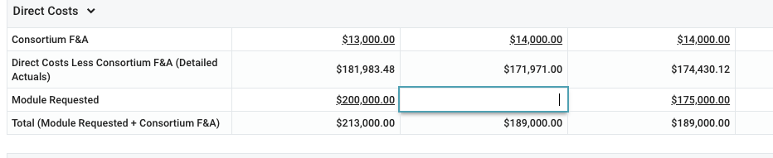

If you change your mind, click Sync to go back to the original amounts.


To check calculations for a more complex budget, click the “Rules and Calculations” button (next to the Sync button). This section explains the rules and calculations for the Indirect Cost Base field selected. In this example, the calculations for period 1 are shown in the right column. Click the X at the top right corner of the right column to close

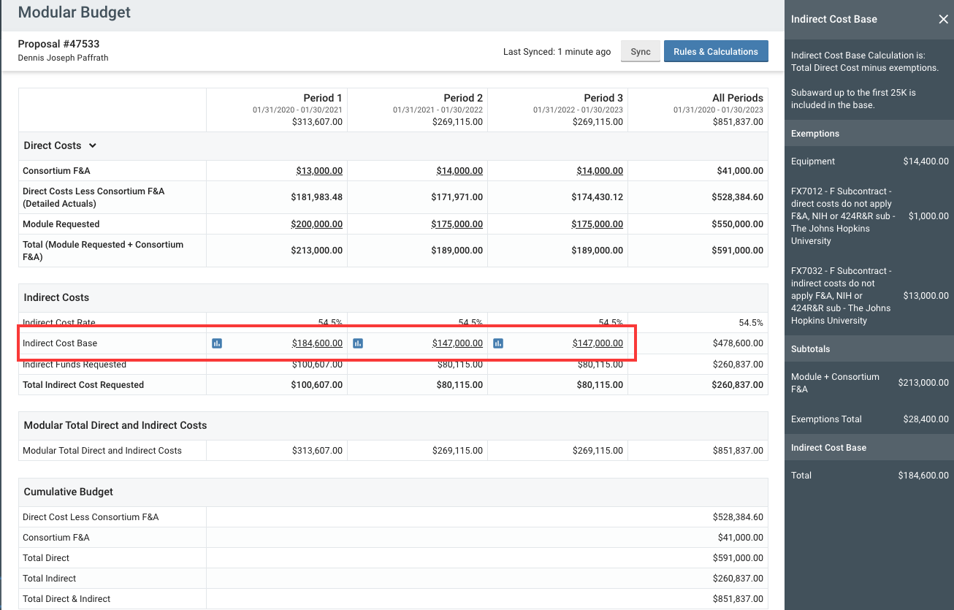

Return to your proposal.
To return to your proposal, if you have closed the left navigation column, re-open it using the small arrow at the bottom corner of your screen.

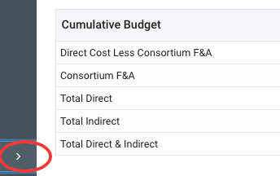

Then select “Go to Detailed Budget” from the menu.

Navigate to Attachments. Upload the modular budget justification attachment(s) appropriate for your budget. Review instructions for modular budget justification documents:
http://www.umaryland.edu/spa/budgets-and-expenses/nih-modular-budgets/
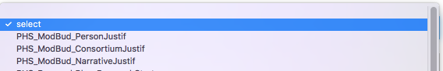

Navigate to Basics > S2S Opportunity Search > Forms tab.
Check the box to INCLUDE the modular budget in the submission to Grants.gov and eCommons.
To see how the budget will look when submitted to NIH, select the Modular Budget form in the right column and click Create PDF in the bottom right corner of the page. A PDF document will be generated. Depending on your own computer and browser settings the document will either download to your computer or appear on the screen.
NOTE: Do not “Include” the Subaward Budget on the S2S Forms page since this is a Modular budget.
