Kuali Research Proposal Development Walkthrough
  - for proposals that will be submitted system-to-system (KR to Grants.gov)

Contact your SPA Team to arrange for one-on-one training (via WebEx or Zoom)

Please use the separate Budget Walkthrough document for instructions on entering budgets in Kuali Research.

Page 2: Log-in to Dashboard
Page 3: Create Proposal
Page 5: Proposal Details
Page 7: S2S Opportunity Search
Page 9: Delivery Info
Page 9: Sponsor & Program Information
Page 10: Organizations & Locations
Page 13: Key Personnel
Page 17: Compliance
Page 19: Attachments
Page 23: Questionnaire
Page 24: Access (Permissions)
Page 25: Supplemental Information
Page 26: Summary/Submit
Page 26: Data Validation
Page 28: Include Forms
Page 29: Submit for Review
Page 30: Actions after Submit for Review (update attachments; recall; add viewer)

More resources are at UMB’s Kuali Research website

Log in to Kuali Research

If your left navigation menu shows only icons, you may wish to open it, using the > at the bottom left corner of the screen.

From the left navigation menu screen, select Common Tasks.
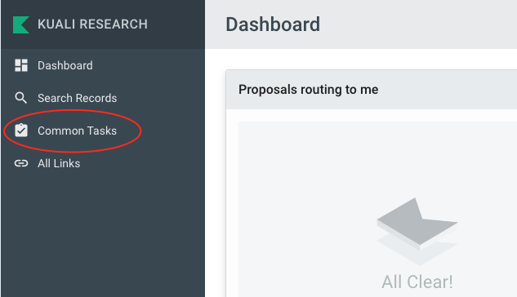
In the Proposal Development card, click on Create Proposal
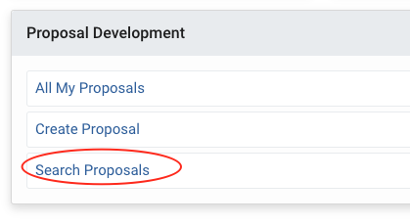

NOTE: to edit an existing proposal, choose Search Proposals and click “edit” to open the proposal in edit mode
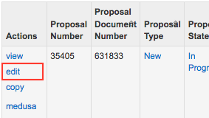

Create Proposal
On the Create Proposal screen, complete all the fields.

NOTE: In Proposal Development, any field marked with an * must be completed. Fields may be required even if they are not marked with an *

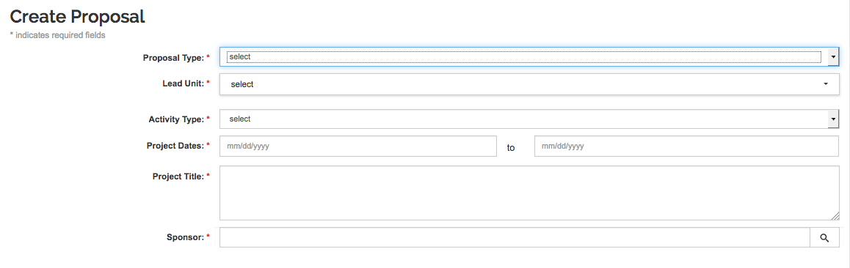

Select Proposal Type

Select Lead Unit. Be certain that the Lead Unit is correct as it cannot be changed once you save the information on the screen.

- For most investigators, select the department where the Principal Investigator has their academic appointment.
- For SOM investigators who are appointed to a Center or Institute, select the Center or Institute as the Lead Unit.

HINT: To change the lead unit after the proposal has been created, either begin again with a new proposal, or COPY the proposal with a change to the lead unit.

A Principal Investigator who is initiating a proposal will usually have access to only one unit in the dropdown menu. Administrators who initiate proposals for multiple investigators may have multiple units to choose from.
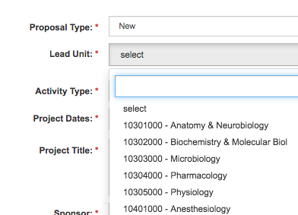

Select Activity Type

Enter Project Dates. Enter the start and end dates for the entire proposal. Click in the field to access a calendar tool, or enter dates as follows: MM/DD/YYYY
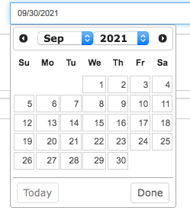

Enter the Project Title. This is limited to 200 characters for Grants.gov proposals. Some sponsors require shorter titles. Do not use special characters in the title, use “smart quotes,” or copy and paste text from other word processing programs such as MS Word.

Select the Sponsor. There are two ways to search:
- Start typing part of the Sponsor No. or Sponsor Name in the predictive text search. Scroll through the results that appear and click on the correct sponsor to select.

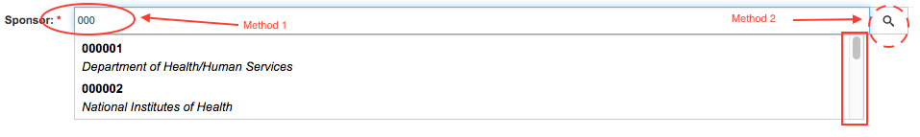
- Use the magnifying glass at the right side of the Sponsor field to open the Sponsor Lookup. You may use wildcard searches (asterisks) in most of the lookup fields (for example: *Defense*). Click “select” to the left of the correct sponsor.
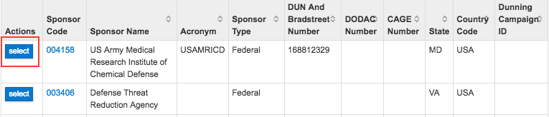

NOTE: If the needed Sponsor is not listed, please complete the Address Request form and request to add a new sponsor. For corporate sponsors, a name is required for a contact person. http://www.umaryland.edu/kualicoeus/user-access-and-requests/address-request/

When all fields on this screen have been completed, click “Save and Continue” at the bottom of the page.

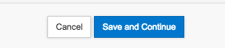

Proposal Details
Now you may begin completing the rest of the proposal.
Make a note of the Proposal Number so that you can easily find the proposal again for future editing. The proposal number is in the top left corner of the page.

Note that the left navigation menu and the top menu (“Proposal Tab Bar”) have appeared.

All fields are editable except the Lead Unit.
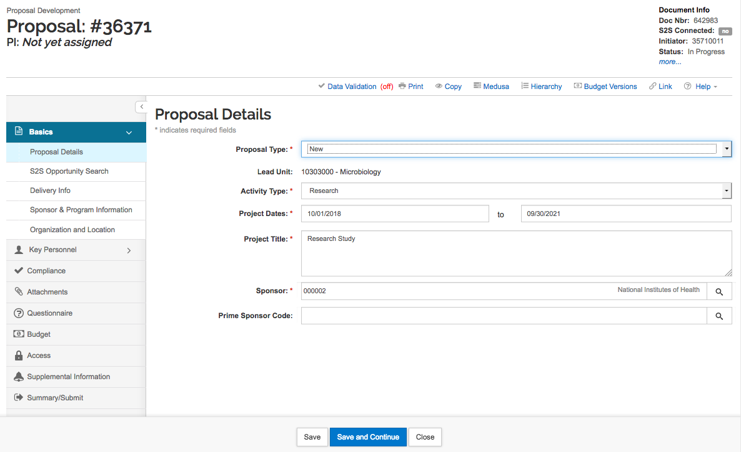

If the proposal were a subaward proposal, you would add the Prime Sponsor here. For example, if Cornell University is applying for an NIH proposal, and UMB is participating as a subrecipient in the Cornell proposal, the Sponsor would be Cornell University. This type of proposal would not be submitted system-to-system to the federal Prime Sponsor through Kuali Research, but would be submitted to the Sponsor (i.e., Cornell in our example) for submission.
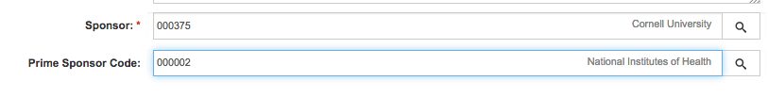

Click “Save and Continue” and KR will take you to the next section of the proposal to be completed. Click “Save” if you want to stay on the same page.
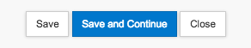

HINT: Kuali Research will automatically take you to the next section in sequence when you use the “Save and Continue” function. Or, you may use the left navigation buttons to select a specific section to enter or review.

Instructions for system-to-system proposals (submitted via Grants.gov to the federal funding agency directly through Kuali Research)

S2S Opportunity Search

When you choose a federal sponsor that is eligible for system-to-system (S2S) submission, Kuali Research takes you to the S2S Opportunity Search section to link to the funding opportunity announcement.

Look up the Funding Opportunity Announcement number using Grants.gov or the NIH website.
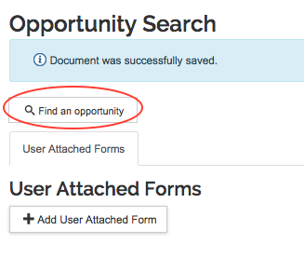
On the S2S Opportunity Search section, click the Find an opportunity search button

A search screen will open in a pop-up window. The Search Domain is Grants.gov. Enter the Opportunity ID. At the bottom of the window, click Search.
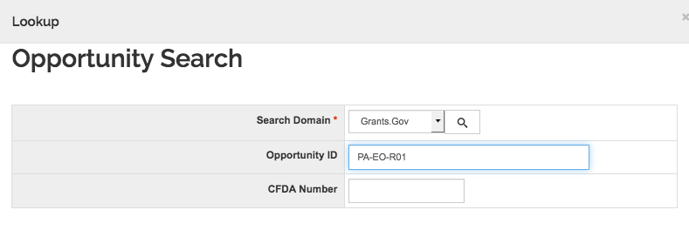
Check the opening and closing date of the opportunity to make sure it is active. Click Select to the left of the opportunity.
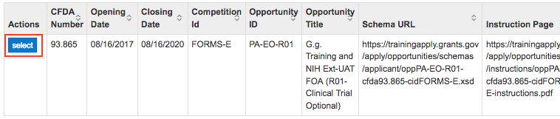
If the opportunity you searched for does not appear in the results or if you get an error message, this particular funding opportunity may not be available for “system-to-system” submission. Contact your SPA team to confirm and to determine if User Attached Forms are available to resolve the error. With SPA approval, you may prepare the proposal for submission via Grants.gov Workspace or NIH ASSIST and use Kuali Research to route the proposal for approvals.

When the opportunity has been linked to Kuali Research you will see the opportunity information and tabs across the page.
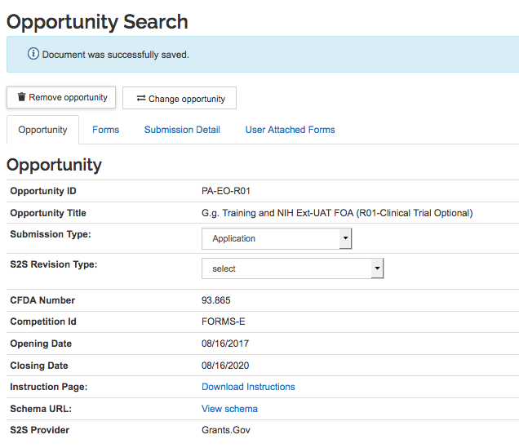
When the opportunity has been linked to Kuali Research you will see the opportunity information and these additional tabs across the page:
Forms: Identify the correct subaward form if needed. Forms may be printed (to PDF) later in the process, after data and attachments have been added to the proposal.
Submission Detail: Will be populated after submission of the proposal to Grants.gov
User Attached Forms: If applicable, complete and upload the PHS Assignment Request Form and other User Attached Forms specific to an opportunity.
On the upper right corner of the proposal, the document data now show that the proposal is S2S connected.
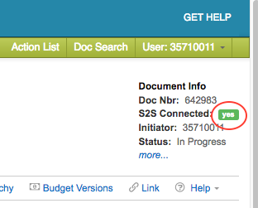

Delivery Info
Since this proposal is a federal proposal being submitted system-to-system (aka “S2S”; i.e., Kuali Research to Grants.gov), Delivery Info is not required.

Click “Save and Continue” to move to the next screen.

Sponsor & Program Information
Enter the Sponsor deadline. A calendar tool will appear, or enter the date as follows: MM/DD/YYYY

Enter the Sponsor Deadline Type

Subawards: Click the checkbox if the proposal budget will include subaward funding for another organization.

NSF Science Code: For research proposals (activity types Research-Applied, Research-Basic, and Research-Development), the NSF Science Code is required. Work with your PI to select the closest match.

Other fields may need to be completed for some proposals, including renewals and resubmissions.

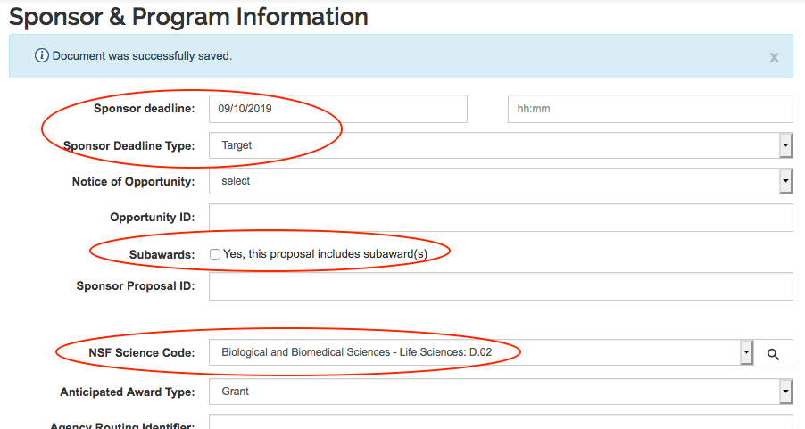

Organizations & Locations
This page has four tabs across.

- Application Organization: do not change
- Performing Organization: do not change
- Performance Site Locations: add at least one UMB performance site. Performance Sites are locations other than proposed subrecipients where investigators will perform project work. The building address is sufficient — more detail such as room number is not needed. External locations are appropriate here if UMB will not issue a subaward to the organization/location.
- Other Organizations: These are your subrecipients. Add any organization that is participating as a subrecipient (the proposal budget will include subaward funding for the subrecipient).

NOTE: At least one UMB performance site MUST be entered. KR currently has no validation for this requirement, but your proposal may be returned by your Dean’s Office or by SPA if this information is missing.

To add a Performance Site Location, select the third tab, and click Add Performance Site. 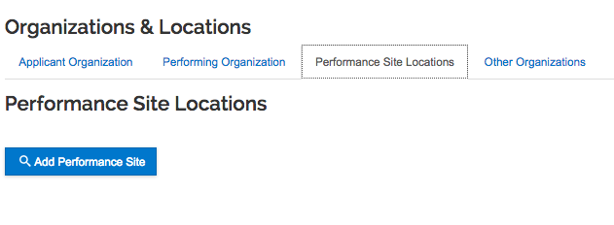

The Address Book lookup will open in a pop-up window. Search for an address book ID that you know, or use wildcard search (asterisks) to look up an address (for example, *22 S* to look up 22 South Greene St addresses): 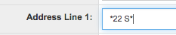

HINT: To get a list of UMB buildings, enter UMB in the last name field. Several pages of results (over 80) will appear: 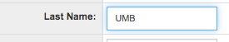

NOTE: Please use existing UMB addresses; the building is sufficient without more details (lab name, floor, room). However, if the needed Performance Site is not listed, please complete the Address Request form and request to add a new Performance Site. http://www.umaryland.edu/kualicoeus/user-access-and-requests/address-request/

For every performance site, you must enter a Congressional District.
Below the address, click +Add Congressional District.
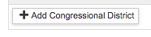

Select the State. Enter 3 digits in the District Number field. Click Add.
For on-campus sites, the Congressional District is MD-007.
For Washington DC, enter DC-098
For non-U.S. sites, enter 00-000 (00 will be a selection in the State drop-down menu)

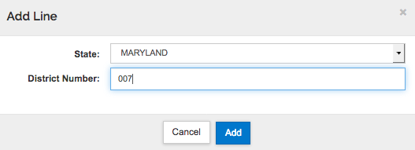

Other Organization refers to subrecipients that will participate in this proposal including subaward funding as part of the budget.
To add an Other Organization (subrecipient), select the fourth tab and click Add Organization.
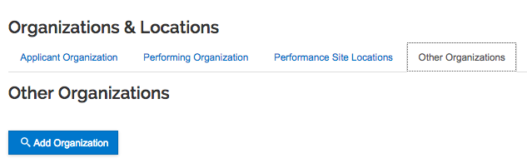

The Organization lookup will open in a pop-up window. Search for an Organization ID that you know or use wildcard search in the Organization Name field and select from the results.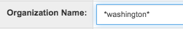

NOTE: If the needed Subrecipient is not listed in the Organization lookup, please complete the Address Request form and request to add a new subrecipient. http://www.umaryland.edu/kualicoeus/user-access-and-requests/address-request/ Request the DUNS, EIN and Congressional District information from your subrecipient contact.

Key Personnel
Key Personnel are the program director/principal investigator (PD/PI) and other individuals who contribute to the scientific development or execution of a project in a substantive, measurable way, whether or not they request salaries or compensation.

Click “Add Personnel”
The search will open in a pop-up window. Add the UMB Principal Investigator first.
Enter the search information in the Employee search window and click “Continue”

NOTE: Limit the search to UMB employees only by entering the Campus Code: 02

DO NOT enter UMCP employees as Key Personnel. They are to be entered from the non-employee look-up.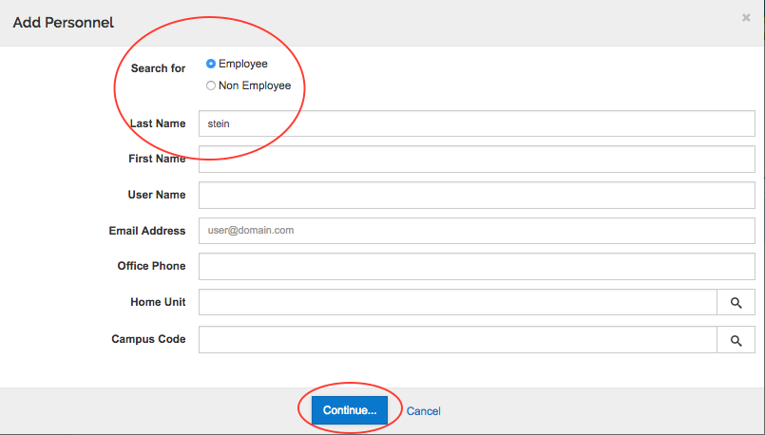

From the results, select the appropriate person and click “Continue”.

NOTE: Selecting Employee for the search will search UMB employees and UMB Affiliates that are in Kuali Research. This list is updated nightly from HR, including the Community System (affiliates). If a needed UMB Key Person is not in the employee lookup in Kuali Research, contact DLKualiResearchHelp@umaryland.edu for troubleshooting.

NOTE: Selecting Non Employee for the search will search the Address Book.
If a needed non-UMB Key Person is not listed, please complete the Address Request form and request to add a new non-UMB person. http://www.umaryland.edu/kualicoeus/user-access-and-requests/address-request/
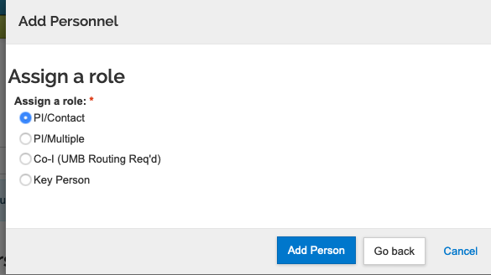

The next screen is “Assign a Role”.

- PI/Contact: UMB’s Principal Investigator for the project; the contact PI for a multiple PI proposal. This role is only used once and does not appear in the list after it is used.
- PI/Multiple: NIH grants only. Use only for UMB investigators. This role is used for the other Principal Investigators from UMB for an NIH multiple PI proposal.
- Co-I (UMB Routing Req’d): USE OF THIS ROLE IS NOT RECOMMENDED – Use the Key Person role instead. If this Co-I role is used for UMB personnel, the proposal will route to that person’s unit, and certification by this investigator may be required by the KR system (even though not required by UMB’s procedures).
DO NOT use for non-UMB personnel. Use the Key Person role instead.
- Key Person: Once selected, you will add a brief description for this person’s role as follows:
  - Non-UMB multiple PI: PD/PI
  - UMB or Non-UMB Co-Investigator: Co-Investigator
  - UMB or Non-UMB other roles: enter the person’s role on the project, such as investigator, OSC or Other Significant Contributor, biostatistician, etc.
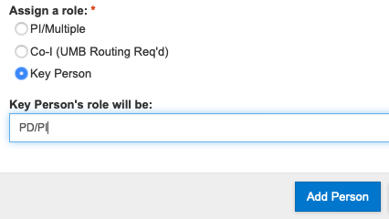

Continue to add Key Personnel as needed for the project.

Person Details

Open a Key Person’s information by clicking the triangle to the left of the person’s name. Opening this panel will reveal seven tabs across the page: Details, Organization, Extended Details, Degrees, Unit Details, Person Training Details, and Certification Questions.

Click on the triangle to the left of the person’s name to open the details for that person. Several tabs are available across the page.

Details tab: For NIH proposals, the eRA Commons User Name is required for PIs and multi-PIs.
ALWAYS UNCHECK “Include in Credit Allocation” – UMB does not use this.

Organization tab: Make sure the email and Office Phone fields are populated. Make sure the Primary and Directory Titles are the same. For U.S. addresses, the Postal code must be 9 digits.

Enter Effort for each key person:

Scroll down to the Effort section.
Add Total Effort. This information is required for every key person listed. Data in the other Effort fields is not required by SPA or CCT.

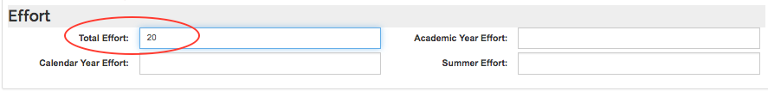

Extended Details tab: contains citizenship information, sometimes required for fellowship or career development proposals. For UMB employees this field defaults to US Citizen. Correct this as needed.

For non-employees, enter the person’s department, institute, or center at their home institution in the Directory Department field.

Scroll down to the Education section
Enter the Year Graduated and the highest Degree. This information should be entered for the PI and may also be entered for other Key Persons.

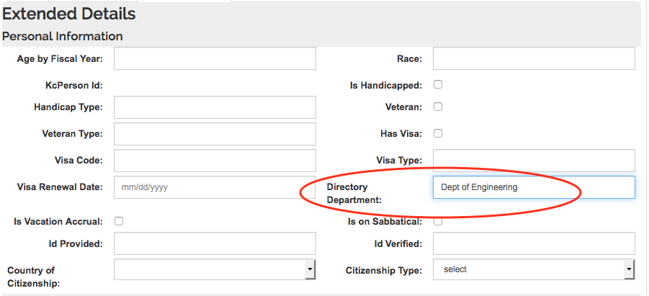

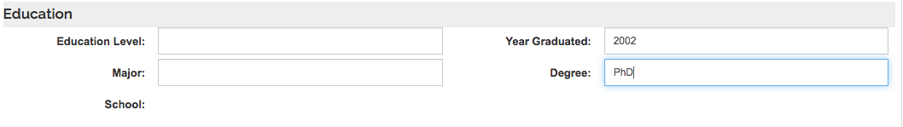

Degrees tab: not needed if completed on Extended Details tab

Unit Details tab: For the PI, when the Lead Unit for the proposal is a Center or Institute, ADD the PI’s unit of academic appointment (“primary appointment”) if it is missing.

Person Training Details tab: Not used at UMB

Certification Questions tab: To be completed ONLY by the Principal Investigator(s). Administrators will not be able to view the questions. A notation next to the Key Person’s name will indicate whether or not the Certification is complete or incomplete. To the far right of the Key Person’s name is a blue button, “Notify All”. Use this button to notify the PI that it is time to certify the proposal. As a best practice, this action should be taken when the proposal is substantially completed.

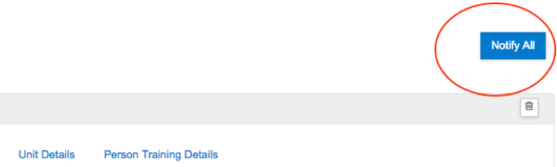

Certification by the PI is required before the proposal is submitted for review into approval routing. The PI and any multiple PIs from UMB must certify. This is an electronic signature from the PI(s) for the proposal and certification cannot be delegated.

NOTE: If for any reason a PI cannot certify electronically, contact your Dean’s Office and SPA to discuss and have a work-around approved.
http://www.umaryland.edu/kualicoeus/user-resources-and-help/certify-or-approve/

HINT: You may edit information for a Key Person such as title, email, or zip code. However, edited information applies only to the specific proposal. Employees should update their information using the “self-service” function for the campus directory or as directed by HR. To have non-Employee information updated, contact DLKualiResearchHelp@umaryland.edu

Compliance
The list of compliance types includes entries used by UMCP and items that may be used by UMB in the future.

Add entries here if the project involves: Human Subjects, Animal Subjects, Radioactive Materials (Ionizing), Recombinant DNA, or Select Agents. (scroll down for Select Agents).

Click +Add compliance entry. The entry screen opens in a pop-up window.
Choose the compliance type.
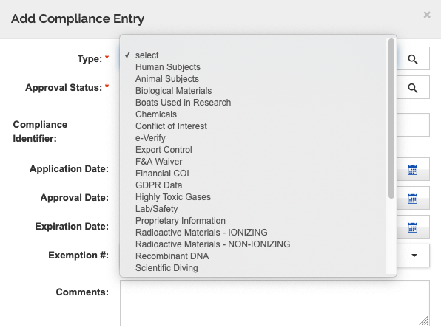

- Select the Approval Status. This field is required for all entries.

- Protocol Number: Required for Approved Human Subjects and Approved Animal Subjects.

- Application Date: Not required

- Approval Date: Required for Approved Human Subjects and Approved Animal Subjects. Should be included for other approved entries such as rDNA and select agents.

- Expiration Date: Not required

- Exemption #: Used for exempt human subjects. Obtain this information from the IRB determination.

- Delayed Onset (Additional checkbox field specific to Human Subjects): Check if the study meets the NIH definition for delayed onset. When checked, a Study Title box appears. Enter the study title for the Delayed Onset study. If the proposal involves more than one study (active or delayed onset), each study title must be unique. At the Human Study Attachment Field, add a PDF attachment describing the Delayed Onset study, as instructed by NIH.

- Clinical Trial (Additional checkbox field specific to Human Subjects): Check if the study meets the NIH definition for a Clinical Trial. At the Human Study Attachment Field, add a completed Human Subject Study Record. This document is an Adobe Form.

- Upload a completed Human Subject Study Record if applicable (Additional field specific to Human Subjects): Use this decision tree to ascertain whether a Human Subject Study Record is needed for your proposal and, if so, how much of it is to be completed: https://www.umaryland.edu/kualicoeus/user-resources-and-help/nih-human-subjects-forms/human-subjects-decision-tree/

- Click Add Entry

- If the project has more than one human subject study, or one active and one delayed onset study, you must add multiple human subject compliance entries.

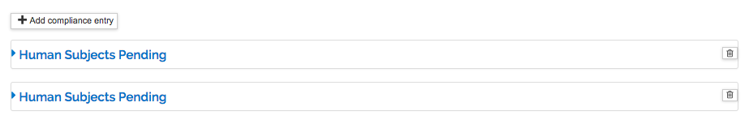
Add more entries as applicable to the project. If the project involves more than one human subjects protocol or animal subjects protocol, add separate entries for each protocol.

More detail for human subjects: https://www.umaryland.edu/kualicoeus/user-resources-and-help/nih-human-subjects-forms/
Tips for completing Adobe forms: https://www.umaryland.edu/kualicoeus/user-resources-and-help/attachments/troubleshooting-adobe-forms/

Attachments
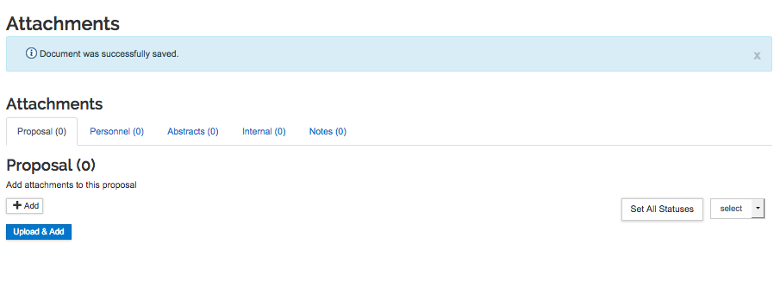
Attachments such as project description, letters of commitment, and funding opportunity announcements are uploaded here. Proposal and Personnel attachments are to be PDF files.
- Attachment file names and descriptions must not contain any spaces or special characters or have >49 characters. Example: UnivOfMaryland2019.pdf
- Every Attachment, including biosketches, subaward budget forms, and the subaward budget justification attachment, must have a different (unique) file name.

This section has five tabs across the page:

Proposal: Upload all attachments required for proposal submission. Checklists of attachments for NIH R-, F-, and K-series proposals are available from the SPA Forms page under Checklists: http://www.umaryland.edu/spa/forms/

Personnel: Upload biosketches; if required, upload current/pending support

Abstracts: Generally, not used at UMB. May be needed for some proposals.

Internal: Use for sponsor instructions, subrecipient F&A rate agreement, and similar documents that will not be shared with the sponsor.

Notes: This tab collects notes entered by aggregators and others.

Upload Attachments:
Select whether you wish to upload attachments individually or upload multiple attachments at once.
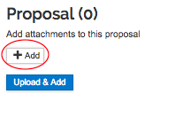
Method 1, +Add - Upload attachments individually:
- Click +Add – attachment tool opens in a pop-up window
- Select Attachment Type – required
- Select Status – final or draft – required
- Description may be required for some attachment types. To avoid errors at Grants.gov or your sponsor follow the program announcement instructions regarding the proper file name and format. If no instructions are provided, we recommend using the following guidance for the Description and File Name:
  - The file name and Description should be unique to each upload for this Attachment Type.
  - The file name should not contain ANY special characters, as other characters or symbols will cause errors in transmission.
  - Use only Numbers 0-9, Uppercase A-Z, or lowercase a-z, Periods (.), dashes (-), and underscores (_)
- Browse for file
- Save
- Other fields are not required by SPA
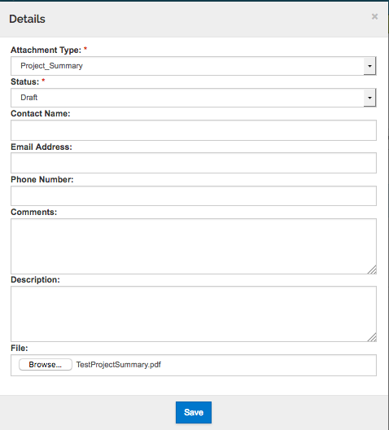

Method 2, Upload & Add - Upload multiple attachments at a time:

Click Upload & Add. This opens your computer’s browser. Locate the files, select one or more files and click “open”. Wait briefly while the files upload into the proposal.

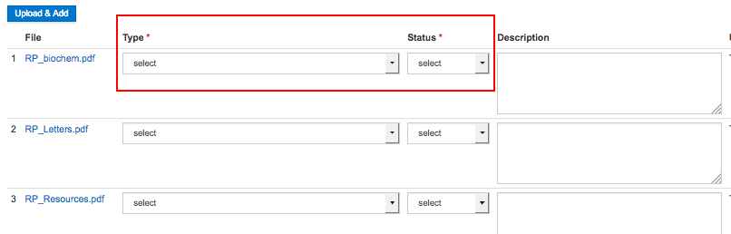

For each file, select the Attachment Type under the Type column, and the Status (draft or final) in that column. For some attachment types, a Description may be required. We recommend limiting the description to 20 characters. To avoid errors at Grants.gov or your sponsor follow the program announcement instructions regarding the proper file name and format. If no instructions are provided, we recommend using the following guidance for the Description and File Name:
- The file name and Description should be unique to each upload for this Attachment Type.
- The file name should not contain ANY special characters, as other characters or symbols will cause errors in transmission.
- Use only Numbers 0-9, Uppercase A-Z, or lowercase a-z, Periods (.), dashes (-), and underscores (_)
IMPORTANT: If you see attachments that appear to be generated by the system, do not attempt to view, change or delete them. For example, if your budget has more than 8 senior persons an Additional Senior Key Persons attachment will be automatically generated and submitted. Do not view, change or delete. You can view all attachments via the S2S section, Forms tab.

DO NOT change “view/edit rights”.

If need be, you may delete an attachment using the trash can on the far right of the attachment line.

To replace the existing file, open the Details tab and browse for the replacement file.
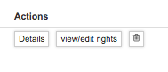
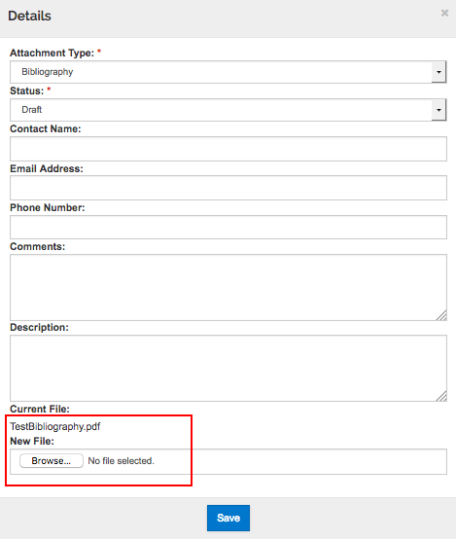

Questionnaire
Questionnaires relevant to your proposal must be completed. One or more tabs will appear across the page. The “UMB Required Question Questionnaire” must be completed for all projects. Initially, the questionnaires will appear with the notation (Incomplete), and a gray checkmark on the tab.

Complete all questions for a questionnaire and Save. Then do the same for the next questionnaire (if any).

Upon completing and Saving a questionnaire, the checkmark turns green and the notation changes to (Complete)

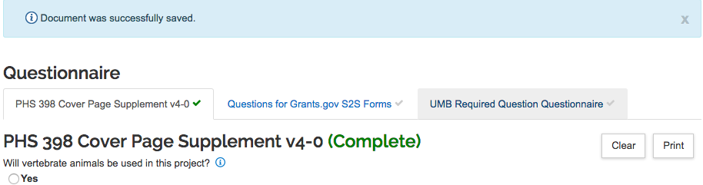

Budget
Please go to the separate “KR Budget Guide” to learn about budgets in Kuali Research.

Access
- The person who created the proposal appears on this tab as having permission to edit the proposal.
- Persons with UMB Pre-award Department user roles in a unit should have the ability to view and edit proposals for that unit.
- Long-time PIs will likely have a Kuali Research User Profile with “UMB PI” roles for their academic unit. Make a request for UMB PI roles for new faculty, postdocs, students, and others who will have the role of PI or Multi-PI for a proposal. This user role in Kuali Research allows the investigator to view and edit a proposal when they have the PI or Multi-PI role on that proposal.
https://www.umaryland.edu/kualicoeus/user-access-and-requests/add-user-roles/
- Person(s) with the PI and Multi-PI roles on the Key Personnel tab may be able to View and Certify the proposal. If not, add them here with the role “Aggregator Only Document Level”
- Add SPA staff with “Aggregator Document Level” permissions, as some edits may be required as part of SPA’s review.
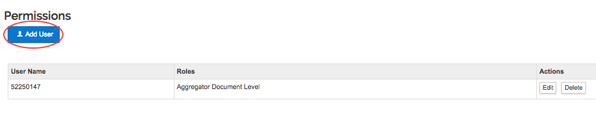
Click Add User
The search screen (Employee look-up) will open in a pop-up window.
Search for a UMB employee or affiliate
Select the person using the circle to the left of the name and click Continue.
Next, assign a role. Check the box next to the role name.
Click the Add Permission button.

Typical roles:
- Aggregator Only Document Level: Used for the PI and Multi-PIs and for department viewers who may need to edit or upload attachments to the proposal
- Viewer Document Level: Used for department viewers who will not need to edit, such as administrators for collaborating departments or co-investigators
- Aggregator Document Level: Used for SPA staff and anyone who should have the same rights as the document creator (for example, use this role for multiple research administrators in a department who all need access to proposals)
More information: https://kuali-research.zendesk.com/hc/en-us/articles/115011806167

To edit or delete roles, use the Action buttons at the right of the data line.

Supplemental Information
This section includes UMB-specific data.
Select the tab labeled “Baltimore – General”
Respond to the COVID-19 question.
Enter the Financial Department. This is the unit that will manage the award if an award is made, that is, the unit associated with the Project ID for the award.
Enter the unit number; as you enter the digits, suggestions will appear. To look up the unit number, click on the magnifying glass.
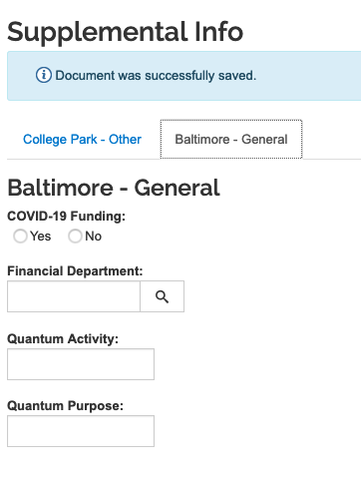

If the Quantum Activity and Quantum Purpose fields are completed, the data will be provided to SPAC for Project set-up.

Summary/Submit
This section contains a proposal summary and other information from the proposal for review. Tabs for each section appear across the page.
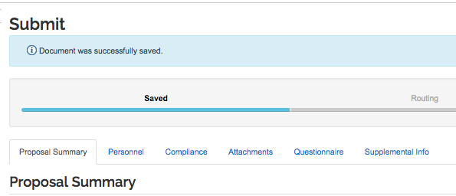

Before you submit

Validate the data in the proposal
At the top of each screen in the proposal, the menu bar include “Data Validation”. You can validate data at any time. It is essential to validate before you “Submit for Review”.
Click the Data Validation link.
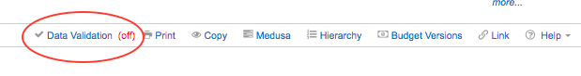

In the pop-up window, click the red “Turn On” button
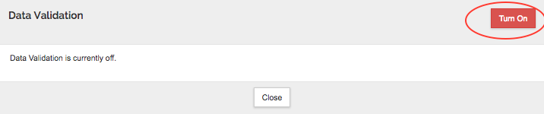

After the system completes validation, usually in a minute or two, this window will show Errors and Warnings. Errors prevent submission for review/approval. Warnings are for information and may need to be corrected, but warnings will not prevent you from submitting for review. Clicking the Fix It link (at the right of the specific validation issue) may take you to the correct section to fix the error. If the Fix It link takes you to the S2S Forms page, select each separate form to print and more specific error messages will appear if there are problems with the Questionnaire, Key Person details, or Attachments.
https://www.umaryland.edu/kualicoeus/user-resources-and-help/validation-errors-warnings/

Contact your SPA Team for assistance with troubleshooting.

NOTE: We recommend that you Turn Off the Data Validation if you plan to continue working on the proposal; the tool validates constantly as you work and results in slower response time in the system.
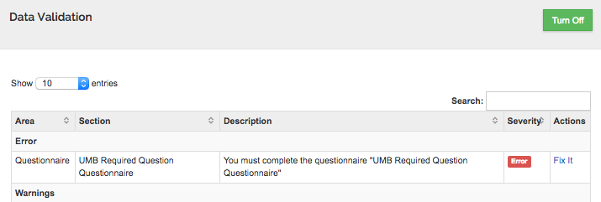

Notify the PI to certify the proposal
If the proposal is completed, this is a good time to notify the PI to certify the proposal.

From the Data Validation results, click Fix It, or use the left navigation menu to navigate to Key Personnel > Personnel. Then Notify the PI(s) who need to certify.
Detailed instructions for the PI are at this web page:
http://www.umaryland.edu/kualicoeus/user-resources-and-help/certify-or-approve/

Include Forms for submission to Grants.gov

Use the left navigation menu to navigate to Basics > S2S Opportunity Search
Select the Forms tab
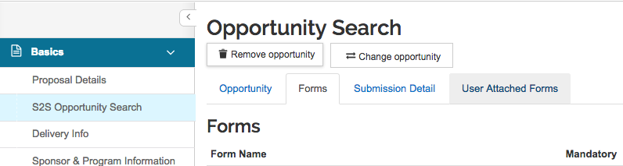

In the Include column of the Forms tab, mandatory forms and any User-Attached forms are marked as “Yes”, meaning that they will be part of the proposal submitted to Grants.gov. Checkboxes are provided for “optional” forms.

For NIH Research grant proposals, in the “Include” column, you must include the appropriate budget form (Detailed OR Modular). If the budget is Detailed and a Subaward is involved, include the Subaward Budget. For different proposals, other forms may need to be “included”.
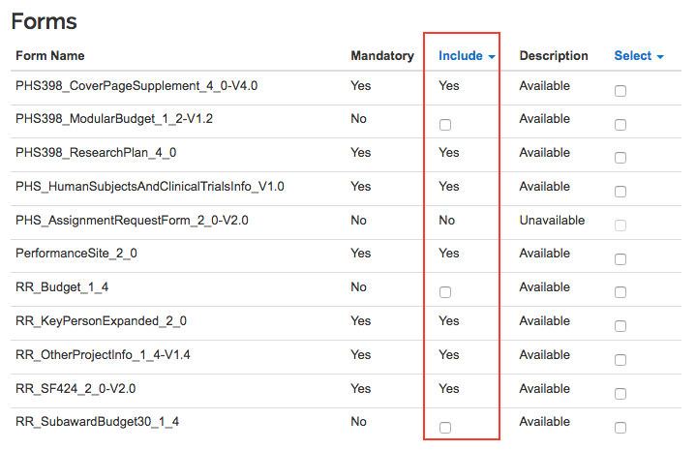

Submit for Review

At the bottom of the page are several action buttons/links
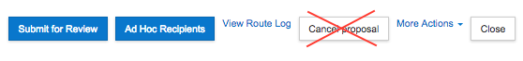
DO NOT click the Cancel Proposal Button: This will inactivate your proposal, and it cannot be undone. If you inadvertently do this, you will need to copy the proposal.

Submit for Review: If the proposal is completed, certified by the PI(s), and passes validations, click Submit for Review at the bottom of the page to submit the proposal into approval routing.

Ad Hoc Recipients: Ad hoc reviewers may be added. In general, this is not needed or recommended.

View Route Log: The Route Log will open in a pop-up window. At any time, before or after you submit for review, you may view the approval actions taken (where it has been), actions pending (where it is waiting), and future actions (where it will go). Click “Show” to view details for each option. Some “stops” are required to approve and some have simply received FYI notifications.

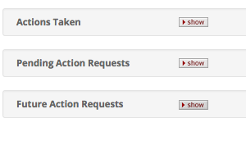
More Actions: There are two options, Send Notifications and Reload Proposal.

Close: Closes the proposal.

Actions After Submit for Review (Proposal status = Approval Pending)

Updating Attachments During Routing

While the proposal is being routed for approval, you may swap out and update attachments.
In the proposal:
- Open Attachments Section
- For the attachment to be changed, click Details at the right side of the attachment line
- Click Browse, select the updated file, and click Save

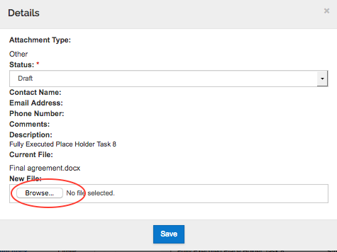
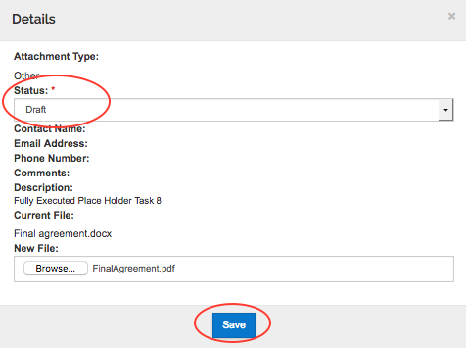

- Be sure the status is Final for all attachments. Change it in Details or on the attachment line.
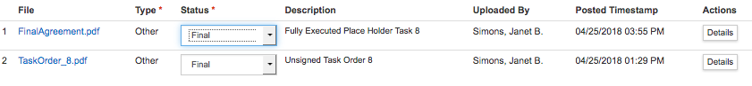
- Note that the Description, if entered, cannot be edited now that the proposal has been submitted for review.

Recall
After you have submitted the proposal for routing, you may recall the proposal in order to make changes. In the proposal:
- Open the Summary/Submit Section.
- Click Recall at the bottom of the page.
- In the confirmation window, enter the reason for a recall and click OK.

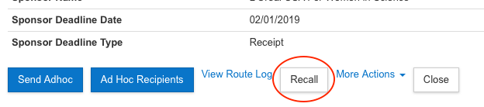
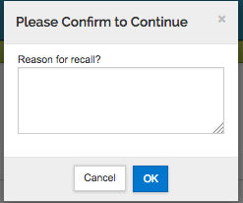

Add a Viewer

Use the left navigation menu to navigate to the Access section. Click the Add User button and proceed as described above on page 24. Only the Viewer role is available to add when the proposal is in the Approval Pending status.

